Medical Rehabilitation in Patient with Right Lateral Epicondilytis - A Case Report

Natalia Nanlohy¹
Joudy Gessal²
Christina Adelle Damopolii²

¹Resident of Physical Medicine and Rehabilitation RSUP Kandou Manado
²Lecture of Physical Medicine and Rehabilitation RSUP Kandou Manado
Email: dr.liananlohy19@gmail.com, joudy.gessal@gmail.com, christinaadelle17@gmail.com

ABTRACT: Epidondylitis is a general term used to describe inflammation, pain, or tenderness in the region of medial or lateral epicondyle of the humerus. Lateral epicondylitis implies an inflammatory lesion with degeneration at the tendinous origin of the extensor muscles. The condition was most prevalent in the age group of 45-54 years. Repetitive movements and forceful activities were correlated with lateral epicondylitis. Patient usually report pain in the area just distal to the lateral epicondyle. They may complain of pain radiating proximally or distally. Patients may also complain of pain with wrist or hand movement. The hallmark of epicondylitis is tenderness over the extensor muscle origin. Initial treatment consist of relative test, avoidance of repetitive motion involving the wrist, activity modification to avoid stress on the epicondyle, anti-inflammatory medications, and thermal modalities such as heat and ice for acute pain. the use of wrist immobilization splints may be helpful. Injection may be useful if therapy and exercise have not provide relief. Surgery may be indicated to those patients with continued severe symptom who do not respond to conservative management. The prognosis of the lateral epicondylitis is excellent if treated appropriately. In our clinic, a 54 years-old female, a housewife, complain pain on the lateral side of the right elbow especially while carrying heavy things. On physical examination we found that there is weakness in hand function and also weakness in action of elbow extension.. The Cozen’s and Mill’s test was performed to this patient and supported the diagnosis. Patient was treated first with Pulsed Ultrasound Diathermy 1 MHz, 1 W/cm2, for ten minutes, two to three times weekly. Because of the pain didn’t decrease in ten times of therapy, we changed the modality therapy with Low Level Laser 3J/cm², 100W/cm², 3 minutes during therapy for 5 weeks. Patient also given ice massage at lateral side of the right elbow and therapeutic exercise.

INTRODUCTION
Epicondylitis is a general term used to describe inflammation, pain, or tenderness in the region of medial or lateral epicondyle of the humerus. Lateral epicondylitis implies an inflammatory lesion with degeneration at the tendinous origin of the extensor muscles (the lateral epicondyle of the humerus). The tendon of the extensor carpi radialis brevis muscle is primarily affected. Other muscles that can contribute to the condition are the extensor carpi radialis longus and the extensor digitorum communis. ¹
A recent demographic study described the epidemiology of this condition and investigated its risk factors in a sample of 4783 people aged 30-64 years. The prevalence in this group was 1.3% and did not differ between men and women. The condition was most prevalent in the age group of 45-54 years. Repetitive movements and forceful activities were also positively correlated with lateral epicondylitis. ²
The elbow complex includes three bones. The biceps, radius and ulna. The ulna is much larger than radius, but distally the radius is much larger than ulna. Three ligaments, two joints, and one capsule. The articulation of the humerus with the ulna and radius is commonly called the elbow joint. On the humerus, the trochlea articulates with the trochlear notch of the ulna and the capitulum articulates with the head of the radius. The elbow is a unaxial hinge joint that allows only flexion and extension. Measured from the 0-degree position of extension, the joint has approximately 145 degrees of flexion. The elbow joint is classified as s ginglymus or hinge-type that allows only flexion and extension. The elbow joint has no active hyperextension. This motion blocked by the olecranon process of the ulna fitting into the olecranon fossa of the humerus. The articulation between the radius and ulna is known as the radioulnar joint. The radioulnar joint is a uniaxial pivot joint, allowing only pronation and supination of the forearm. ^{3,4}
The muscle of the elbow and forearm are as follows : brachialis, brachioradialis, biceps, supinator, triceps, anconeus, pronator teres and pronator quadratus.³
Patient usually report pain in the area just distal to the lateral epicondyle. They may complain of pain radiating proximally or distally. Patients may also complain of pain with wrist or hand movement, such as gripping a doorknob, carrying a briefcase or shaking hands. Patients occasionally report swelling as well.
On examination, the hallmark of epicondylitis is tenderness over the extensor muscle origin. The
common origin of the extensor muscles can be located
Picture1. Anatomy of the Elbow⁴
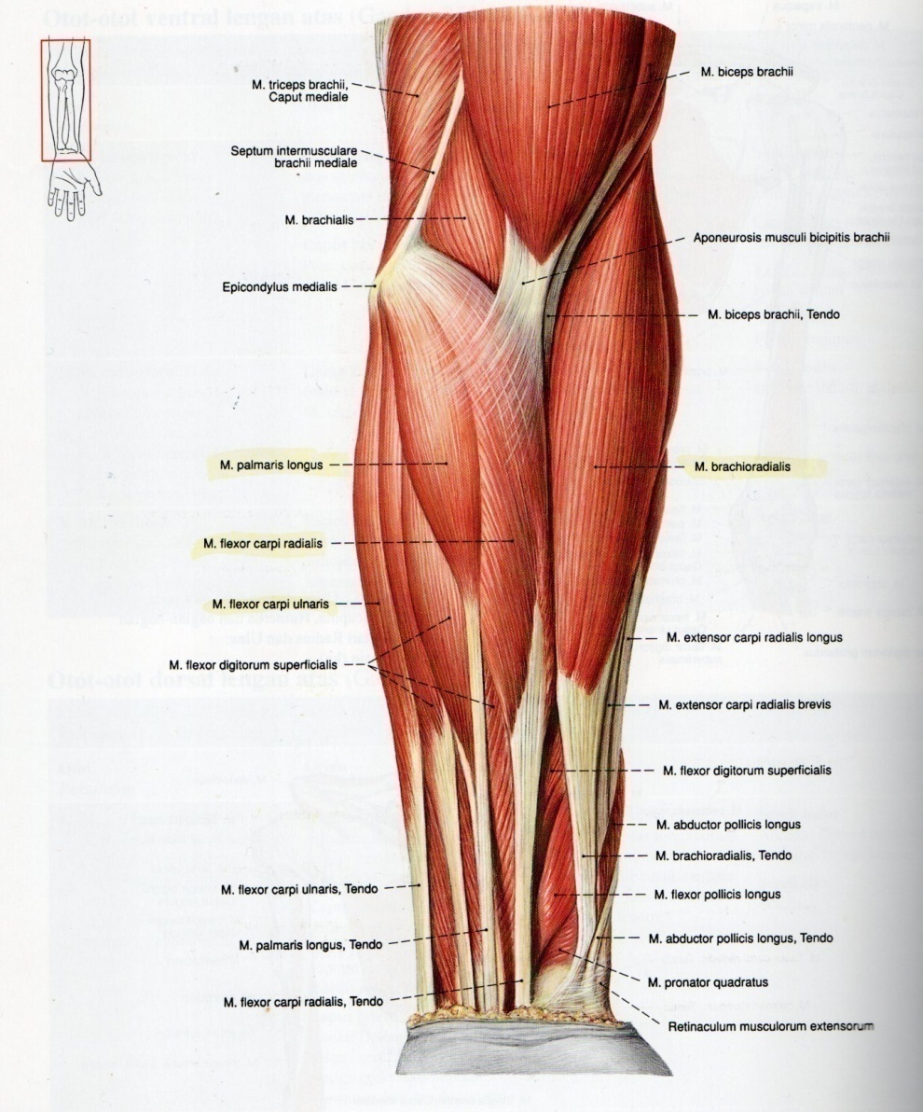

one fingerbreadth below the lateral epicondyle. With lateral epicondyle, pain is increased with resisted wrist extension, especially with the elbow extended, the forearm pronated, the wrist radially deviated, and the hand in a fist. The middle finger test can also be used to asses for lateral epicondylitis. The proximal interphalangeal joint of the long finger is resisted in extension and pain is elicted over the lateral epicondyle. Swelling is occasionally present. The radial nerve can become entrapped just distal to the lateral epicondyle where the nerve pierces the intermuscular septum (between the brachialis and brachioradialis muscles). There may be localized tenderness along the course of the radial nerve around the radial head. Motor and sensory findings are usually absent.
Differential diagnosis for lateral elbow pain are Cervical Radiculopaty, Panners disease, lateral collateral injury, synovitis, etc. ⁵
The patient may complain of an inability to lift or carry objects on the affected side secondary to increased pain. Typing, using a computer mouse, or working on a keyboard may recreate the pain. Even handshaking or squeezing may be painful in lateral epicondylitis. Athletic activities may cause pain, especially with acute increase in repetition, poor technique, and equipment changes.
The diagnosis is usually made on clinical grounds. Magnetic Resonance Imaging (MRI), which is particularly useful for soft tissue definition, can be used to asses for tendinitis, tendinosis, degeneration, partial or complete tears, and detachment of the common extensor tendons at the lateral epicondyle. MRI rarely needed, however except in recalcitrant epicondylitis, and it will not alter the treatment significantly in the early stages.
Initial treatment consist of relative test, avoidance of repetitive motion involving the wrist, activity modification to avoid stress on the epicondyle, anti-inflammatory medications, and thermal modalities such as heat and ice for acute pain.
In addition, a forearm band (counterforce brace) worn distal to extensor muscle group origin can be beneficial. Alternatively, the use of wrist immobilization splints may be helpful. A splint set in neutral can be helpful for lateral epicondylitis by relieving the tension on the flexors and extensors of the wrist and fingers.
Rehabilitation may include physical or occupational therapy. Therapy should include two phases. The first phase is directed at decreasing pain by physical modalities (ultrasound, electrical stimulation, phonophoresis, cortisone iontophoresis, myfascial release, heat, ice, massage) and decreasing disability (education, reduction of repetitive stress, and preservation of motion). When the patient is pain free, a gradual program is implemented to improve strength and endurance of wrist extensors and stretching. The patient should start with static exercises and advance to progressive resistive exercises (with an emphasis on the eccentric phase of the exercise). Thera-Band, light weights, and manual (self) resistance exercises can be used. Work or activity restriction or modification may be required for a time.
Injection may be useful if therapy and exercise have not provide relief. Injection of corticosteroid, usually with a local anesthetic, into the area of maximum tenderness has been shown to be effective in the short-term treatment of lateral epicondylitis. Exacerbating activities are to avoided.
There is no specific technology for the treatment or rehabilitation of this condition. Surgery may be indicated to those patients with continued severe symptom who do not respond to conservative management. For lateral epicondylitis surgery is aimed at excision and revitalization of the pathologic tissue in the extensor carpi radialis brevis and release of the muscle origin.
The Prognosis of the lateral epicondylitis is excellent if treated appropriately.⁶

CASE REPORT
In this case report, we discuss about a 54 years old female patient who was diagnosed with lateral epicondylitis of the right elbow. The diagnosis was constructed by anamnesis, physical examination.
Patient comes with chief complain pain on the lateral side of the right elbow especially while carrying heavy things. According to the literature patient usually report pain in the area just distal to the lateral epicondyle. ¹
In this patient pain on the right elbow felt since 3 weeks ago especially while carrying shopping bags using right hand and do the housework like cooking, grooming, and lift some heavy objects like flower pot when she was gardening.
Pain around the lateral epicondyle is known by a variety of names, and describe as periostitis, extensor carpi radialis brevis (ECRB) tendinosis and epicondylalgia. The most commonly used names are “tennis elbow” and “lateral epicondylitis”. Tennis elbow or lateral elbow tendinopathy is most readily diagnosed with palpation directly over lateral epicondyle at the origin of the extensor carpi radialis brevis (ECRB). This distinguished from the area of pain caused by radial tunnel syndrome, and although the two are often confused they are two separate anatomic locations and entities with different pain pattern. ^{2,7}
Lateral Epicondylitis implies an inflammatory lesion with degeneration at the tendinous origin of the extensor muscle (the lateral epicondyle of the humerus). The tendon of the extensor carpi radialis brevis muscle is primarily affected. ¹ In this case patient was complain that she couldn’t hold something tight as well as her left hands. On physical examination we found that there is weakness in hand function and also weakness in action of elbow extension. According to the literature a common problem associated with the muscles of the elbow is “tennis elbow”, which usually involves the extensor digitorum muscle near its origin on the lateral epicondyle. This condition, known

Picture2. Patient with lateral epicondylitis has local tenderness and pain directly over the midpoint of the lateral epicondyle when the wrist is extended against resistance.⁹
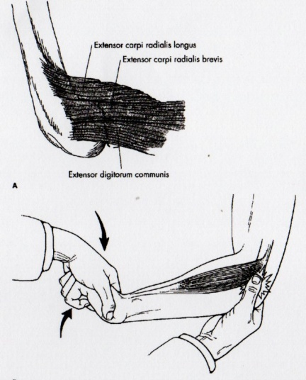
technically as lateral epicondylitis, is quite frequently associated with gripping and lifting activities. ⁸
This patient is not a tennis player. She is 54 years old woman with daily occupation as a housewife. According to the literature, most patient with lateral epicondylitis are between 30-55 years, and many have poorly conditioned muscles. Ninety-five percent of tennis elbow occurs in non-tennis players. ⁹
Based on the literature, the hallmark of epicondylitis is tenderness over the extensor muscle origin. The common origin of the extensor muscles can be located one finger below the lateral epicondyle. In lateral epicondylitis, pain increased with resisted wrist extension, especially with the elbow extended, the forearm pronated, the wrist radially deviated, and the hand in a fist. ¹
According to the literature the tendon of the extensor carpi radialis brevis muscle is a primarily affected. ¹. The extensor carpi radialis brevis muscles lies next to the extensor carpi radialis longus muscle. It arises from the common extensor tendon on the lateral epicondyle. It passes under two tendons that go to the thumb and then under the extensor retinaculum. Its distal attachment is at base of the third metacarpal. Because its attachment is close to the axis of motion for radial and ulnar deviation, it is only assistive in radial deviation. However, it is a prime mover in wrist extension. It also assist in elbow extension.³
The pathophysiology of this condition is primarily a degenerative overuse process of the extensor carpi radialis brevis and common extensor tendon. Aside from degenerative changes, the histological findings include granulation tissue, micro-rupture, and abundance of fibroblast, vascular hyperplasia, unstructured collagen and notably a lack of traditional inflammatory cells (macrophages, lymphocytes, neutrophils) within the tissue. ¹⁰
The provocative test for lateral epicondylitis are Cozen’s test and Mill’s Test. The Cozen’s test perform by examiner stabilizes the elbow with a thumb over the extensor tendon origin just distal to the lateral epicondyle. Pain in the lateral epicondyle is seen with the patient making a fist, pronating forearm, and radially deviating and extending the wrist against resistance by the examiner. The test may be more sensitive when done in full extension at the elbow.
The Mill’s test performed by passive extension of the elbow with forced flexion of the wrist with radial deviation may precipitate pain at the lateral epicondyle. ⁵
For this patient we use Patient Rated Elbow Evaluation (PRTEE). PRTEE is a questionare to evaluate patient’s pain and functional loss both quick and inexpensive. The use of PRTEE is a way to quickly estimate patients’ self-reported problems. It also a very inexpensive way to evaluate changes is patient’s
Picture3. Cozen’s test
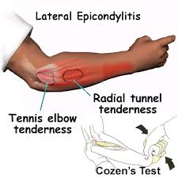

rehabilitation progress, and can be used in research papers.⁶
In non athletes, elimination of the activities that are painful is key to improvement. ¹¹
There are different theorical mechanisms to treat the lateral epicondylitis or tennis elbow and these mechanisms have the same goal representing on pain reducing and functional improvement. The ultrasound, friction massage, strengthening exercise, stretching are the most common modalities which used to rehabilitee the tennis elbow. ¹²
Therapeutic ultrasound is widely used practice in physiotherapy and sport medicine to treat different injures, and this method is focused on the changing the extensibility of the collagenous tissues to improve range of motion. ¹² Patient treated first with Pulsed Ultrasound Diathermy with the dosage 1 MHz, 1 W/cm2, for ten minutes, two to three times weekly. Ultrasound has been used as a therapeutic agent in physical medicine for decades, but although it has been claimed valuable treatment of a wide variety of pain conditions there have been few reports of randomized, controlled clinical trials to evaluate efficacy. Previous studies of continous ultrasound treatment in epicondylalgia and shoulder pain have failed to prove beneficial results for the relief of pain. When using pulsed ultrasound in lateral epicondylalgia, the results are contradictory. In a comparative study of continous ultrasound and pulsed ultrasound, the pulsed ultrasound was favoured. ⁷ Because of patient’s pain didn’t decrease in ten times of therapy with Pulsed Ultra Sound Diathermy then patient was suggest to be given Low Level Laser Therapy with the dose 3J/cm², 100W/cm², 3 minutes during therapy for 5 weeks. Many studies have found that laser therapy may reduce the pain and disability associated with a wide variety of neuromusculoskeletal condition other than arthritis and neuropathy, including lateral epicondylitis. The effects of laser on pain may be mediated by its effects on inflammation, tissue healing, nerve conduction, or endorphin release or metabolism. Analgesic effects

Picture4. Mill’s test
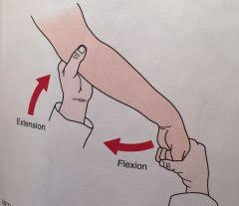

generally are most pronounced when laser applied to the skin overlying the involved nerves innervating the area of the involved dermatome.¹⁴ Low Level Laser Therapy generates a beam of light below the skin. Studies suggest that low-level laser therapy contributes to pain relief by reducing proinflammatory cytokines and increasing anti-inflammatory growth factors and cytokines.¹³
Physiotherapy is classically the first-line treatment for lateral epicondylitis. Among physical modalities, only low-level and high level laser therapy may be effective treatments for lateral epicondylitis. Lateral epicondylitis resolves spontaneously without treatment within 1-2 years. ¹⁴
Surgery is indicated if the symptoms do not resolve despite correctly performed nonoperative treatments in lasting 6 months. ¹⁵
Patient also given ice massage at lateral side of the right elbow. Ice massage has advantages of taking little time to apply to this small area while allowing visualization of the treatment area and assessment or signs and symptoms throughout the intervention, this would be the most appropriate agent to use for this patient. ¹⁶
Therapeutic exercise program for epicondylitis also given for this patient. Evidance suggest that exercise programs can reduce pain, but the improvements in grip strength is less clear. ¹⁷
This exercise program for epicondylitis should be continued for 6 to 12 weeks. The purpose of this program is to stretch and strengthen the muscles attached to the injured tendon will help with the healing process. The early goal of a therapeutic exercise program is to promote muscle endurance and improve resistance to repetitive stress. ¹⁸
This patient is not advised to do a radiographic examination because after several times the physiotherapy is reduced symptoms. In general, lateral epicondylitis is a disease entity that is diagnosed clinically. Imaging is not initially performed but

Picture5. Patient Rated Elbow Evaluation (PRTEE)

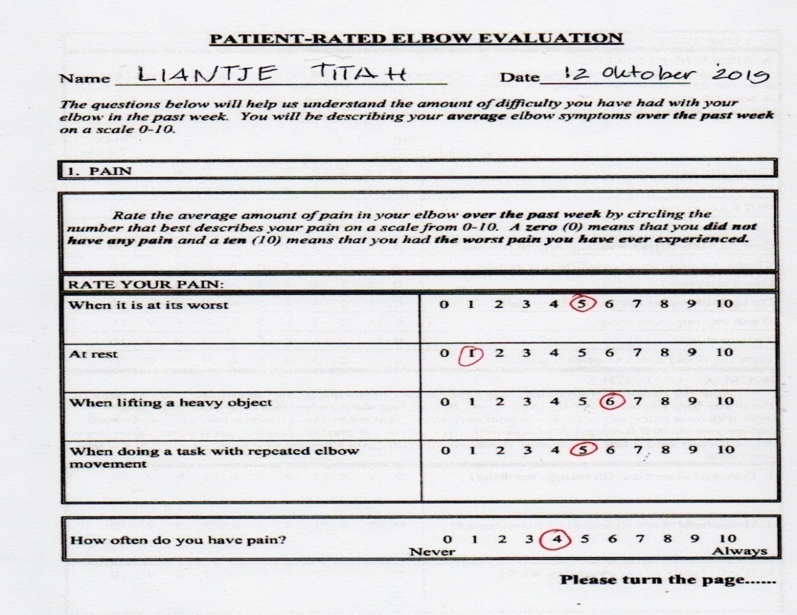

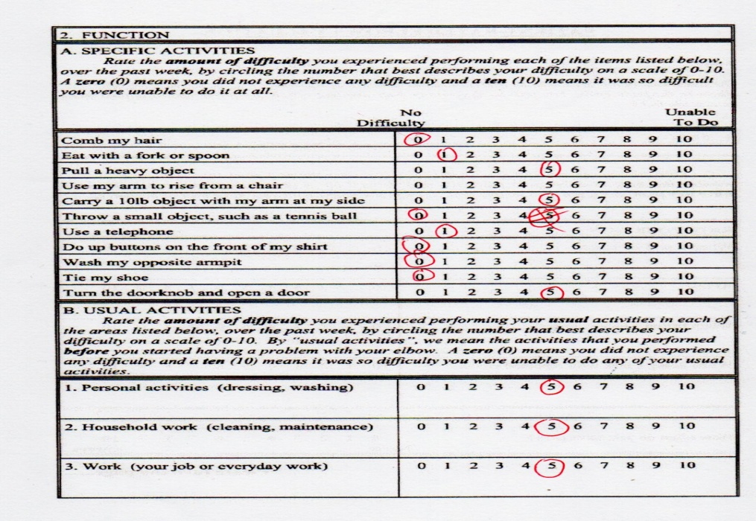

helpful for evaluating disease extent, for excluding other entities that cause lateral elbow pain, and for surgical planning. ¹⁹
This patient was not given a forearm band because the patient claimed to be disturbed by orthotics and felt that he would often forget to wear them. The patient may be prescribed an orthotic device as an treatment strategy; many different types braces and other orthotic devices are available. The chief type is a band or strap around the muscle belly of the wrist extensors. Theoretically, binding the muscle with a clasp, band, or brace should limit expansion and thereby decrease the contribution to force production by muscle fibers proximal to the band.¹⁵

Picture6. Exercise Program for Epicondylitis
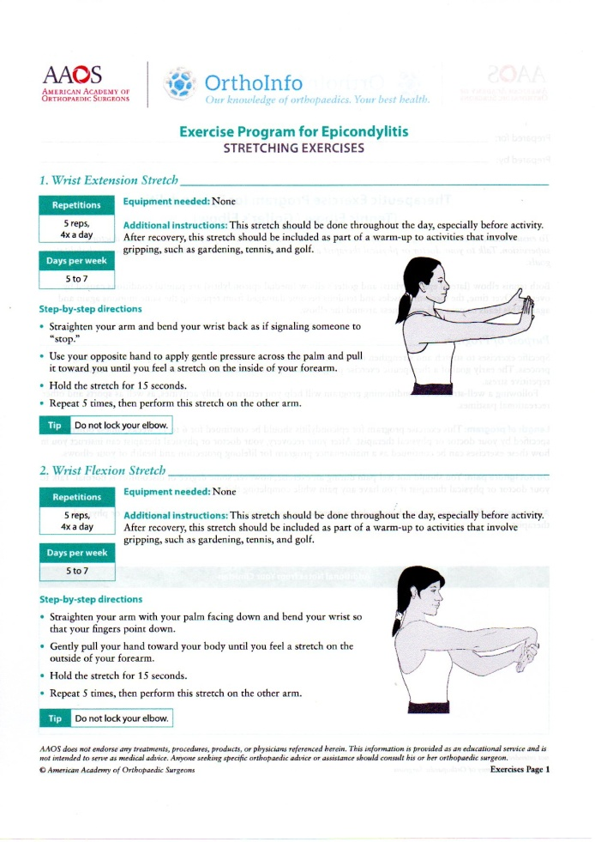

Picture7. Exercise Program for Epicondylitis
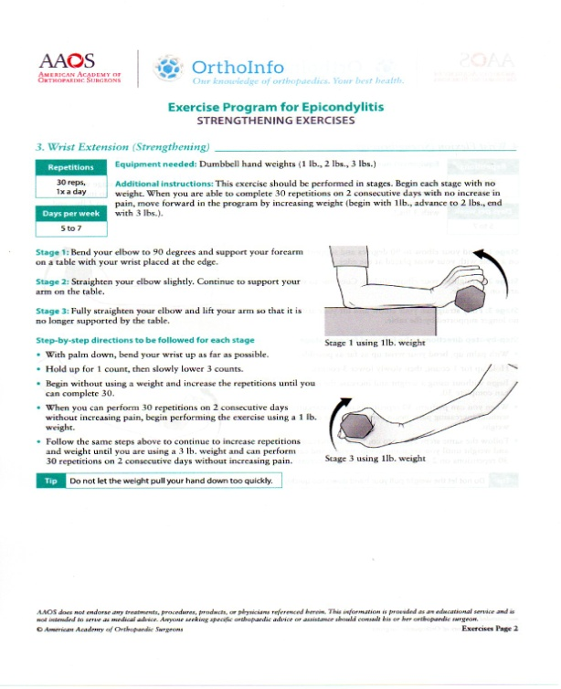

Picture8. Exercise Program for Epicondylitis
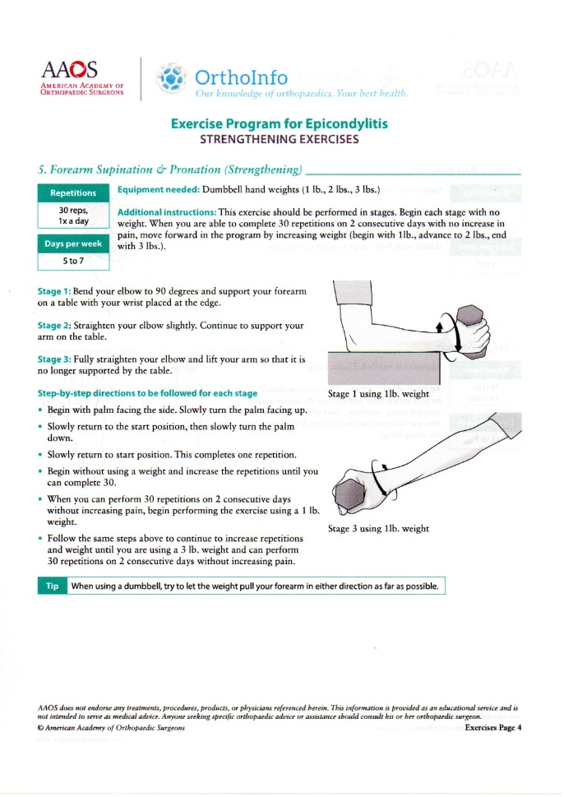

Picture8. Exercise Program for Epicondylitis
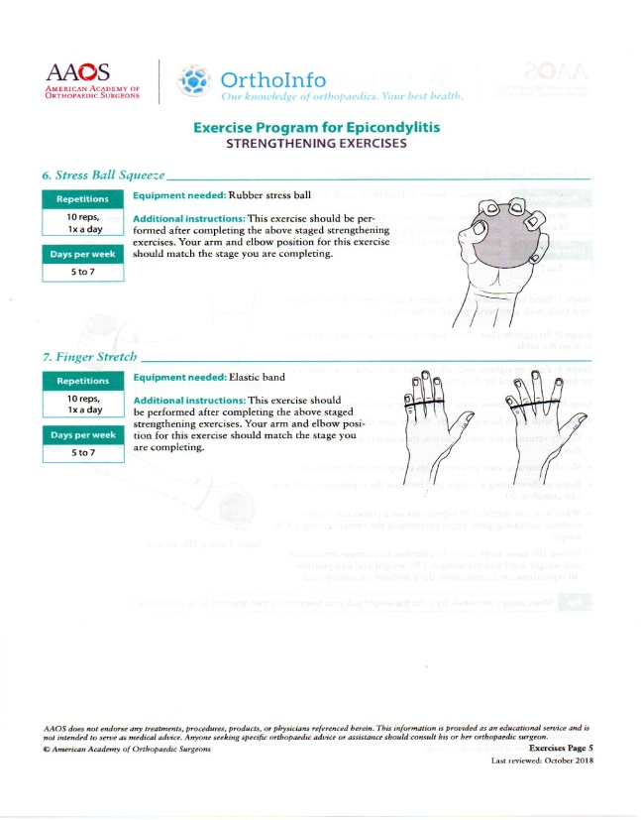

REFERENCES
    - Weiss LD, Weiss JM. Lateral Epicondylitis, Frontera WR, Essential of Physical Medicine and Rehabilitation 3rd Edition. Philadelphia: Elsevier Saunders: 2014
    - De Smedt Thomas, de Jong Andy, Leemput Van Wim, Lateral Epicondylitis in tennis: Update on aetiology, biomechanics and treatment, Br J Sport Med: 2007
    - Lippert LS. Clinical Kinesiology and Anatomy 5th ed. Philadelphia: F.A.Davis Company; 2011.
    - Putz VR, Pabst R. Atlas Anatomi Manusia Sobotta. Edisi 21. Penerbit Buku Kedokteran: 2000
    - Brotzman B.S., Wilk E.K. Clinical Orthopaedic Rehabilitation, Second Edition, Pennysilvania, Mosby, 2003
    - Christer R., The Sport Injuries Handbook Diagnosis and Management. London. 2007
    - OrthoInfo, Therapeutic Exercise Program for Epicondylitis (Tennis Elbow/Golfer’s Elbow).
    - Johnson GW, Cadwallader K, Treatment of Lateral Epicondylitis, Idaho: 2007
    - Floyd R.T. Manual of Structural Kinesiology, Nineteenth Edition. 2015
    - Buchanan K. B., Matthew V., Tennis Elbow ( Lateral Epicondylitis), NCBI Bookshelf. A Service of the National Library Medicine, National Institute of Health, 2019
    - Morrey B. F., Sanchez-Sotelo J., Morrey M.E. The Elbow and Its Disorders, Fifth Edition. Elsevier, 2018
    - Shanheen H, Alarab A, Ahmad M,. Effectiveness of Therapeutic Ultrasound and Kinesio Tape in Treatment of Tennis Elbow. Heighten Science. 2019
    - Da Silva P, Tamaoki MJS, Blummeti FC,. Electrotherapy Modalities for Lateral Elbow Pain (Protocol), Cochrane Library. 2018
    - Lenoir H, Olivier M, Carlier Y,. Management of Lateral Epicondylitis in Orthopedic&Traumatology : Surgery&Research. Elsevier. 2019
    - Dutton M. Orthopedics For The Physical Therapis Assistant. Pennysilvania, 2019
    - Nilson P, Baigi A, Marklund B, Cross-cultural adaptation and determination of the reliability and validity of PRTEE-S (Patientskattad Utvardering av Tennisarmbage), a questionnaire for patient with lateral epicondylalgia, in a Swedish population. In: BMC Musculoskeletal Disorders: 2018
    - Haker E, Lundeberg T, Pulsed Ultrasound Treatment in Lateral Epicondylalgia. In: Scandunavian Journal of Rehabilitation Medicine
    - Cameron MH. Physical Agents in Rehabilitation Fourthe Edition. Pennysilvania. 2013
    - Yeon K.C, Seon-Jeong K, Noh Hyuck Park,, Magnetic Resonance Imaging of Patients with Lateral Epicondylitis : Relationship between Pain and Severity of Imaging Features in Elbow Joints. Korea. 2019

