**Medical Rehabilitation in Patient With Right Transtibial Amputation: A Case Report**

**1Chandra Tanoeisan, 1Joudy Gessal**

*1Physical and Rehabilitation Department of Sam Ratulangi University Manado*

chandratanoeisan@gmail.com, jgessal@yahoo.com

**ABSTRACT**: Transtibial amputation is an amputation of the lower leg between the ankle joint and knee joint, also called below knee amputation (BKA).1,2 Currently amputation of the lower extremities reaches 85%-90% of all amputations and transtibial amputations are the most common type of amputation.3,4 In the United States, a lower limb amputation of 82% is caused by dysvascular causes such as peripheral vascular disease (PVD), Diabetes Mellitus (DM) or chronic venous insufficiency (CVI). Other causes are trauma (16.4%), malignancy (0.9%), and congenital anomalies (0.8%).5 The presence of knee joint in transtibial amputation has significance meaning in the rehabilitation program, allowing the patient to return near-normal gait functions with minimal physical limitations. Rehabilitation in patient with amputation must begin as soon as possible. The goal of rehabilitation is to maximize the patient’s capabilities, function, and independence. We report the rehabilitative course of a middle-aged female patient who did right transtibial amputation due to diabetic ulcer that showed good outcome.

*Key Words: transtibial amputation, BKA, prosthetic, diabetic ulcer.*

**ABSTRAK:** Amputasi transtibia merupakan amputasi pada tungkai bawah dengan batas antara sendi pergelangan kaki dengan sendi lutut, juga disebut amputasi bawah lutut.1,2 Kini, angka kejadian amputasi ekstremitas bawah mencapai 85-90% dari semua amputasi dan amputasi transtibia merupakan yang paling sering.3,4 di Amerika Serikat, amputasi tungkai bawah sebanyak 82% disebabkan oleh penyebab vaskular, seperti penyakit arteri perifer (PAD), diabetes melitus (DM), atau insufisiensi vena kronik. Penyebab lain meliputi trauma (16.4%), keganasan (0.9%), dan anomali kongenital (0.8%).5 Adanya sendi lutut pada amputasi transtibia berperan penting dalam program rehabilitasi, memampukan pasien agar mengembalikan fungsi gait normal atau mendekati normal dengan keterbatasan fisik minimal. Rehabilitasi pada pasien pasca amputasi harus dimulai sesegera mungkin. Tujuan dari rehabilitasi adalah untuk memaksimalkan kapabilitas, fungsi, dan kemandirian pasien. Kami melaporkan program rehabilitasi dan hasil baik yang dicapai oleh wanita usia paruh baya setelah mengalami amputasi transtibial oleh karena ulkus diabetikum.

*Kata Kunci: amputasi transtibia, BKA, prostesis, ulkus diabetikum.*

**INTRODUCTION**

Amputation of the lower extremities reaches 85%-90% of all amputations and transtibial amputations are the most common type of amputation.The presence of knee joint in transtibial amputation has significance meaning in the rehabilitation program, allowing the patient to return near-normal gait functions with minimal physical limitations.1,2 Medical rehabilitation care in amputee patients should begin as soon as possible and handled by a multidisciplinary team.6

The goal of rehabilitation is to maximize the patient’s capabilities, function, and independence. The success of rehabilitation depends on the level of amputation and type of amputation, any premorbid or resulting impairments and disabilities, the patient’s overall health, and family support.With effective prosthetic rehabilitation and prosthetic care, most individuals with amputations can return to the same level of activity and lifestyle as their preamputation status 7

About 75% to 93% of acquired lower limb amputation are the result of vascular disease (diabetes mellitus, peripheral vascular disease and chronic venous insuficiency ) and diabetes contributes to two thirds of all lower limb amputations.7,8 Trauma is the next most common cause for lower limb amputation that usually occurs as a result of an industrial or motor vehicle accident.9,10,11 Traumatic amputation occurs in a younger age population that is in the second and third decades of life.1,7,9,10 In this case report, we have a female patient who has been amputated on her right below knee level (transtibial amputation) due to her diabetic ulcer.

**CASE REPORT**

INITIAL PRESENTATION

A 40 years old woman, housewife, got amputation on her right lower leg because of unhealed wound on her right foot sol and big toe. She had uncontrolled DM but denied any other comorbid. She just went amputation about four months ago but had just gone to rehabilitation due to cost reasons, unable to pay for prosthetic leg. She denied phantom pain but has phantom sensation. Currently she can ambulate and doing basic activity of daily living with bilateral axillary crutches but with some limitation on vocational and feel shame due to her condition. She hopes that she will be able to use prosthetic limb to overcome her shame and limitations.

On admission, she was alert, her vital sign within normal limit and well controlled blood sugar with oral medicine from internist. Her BMI was 24,34 kg/m2 (normal) and chest expansion measurement from maximal inspiration to maximal expiration on axillaris, papillae mammae, and procesus xhypoideus was 97-92 cm, 99-94 cm, and 92-87 cm, respectively. She denied any stump pain or phantom pain, but there was phantom sensation. Locally status on her stump was showed on figure 1 and the examinations were detailed below.

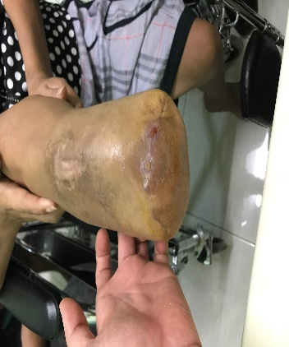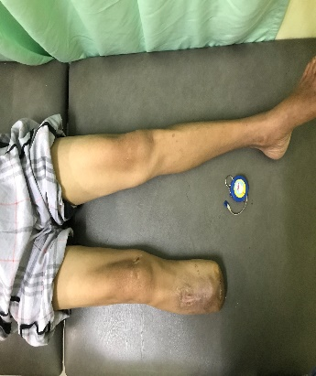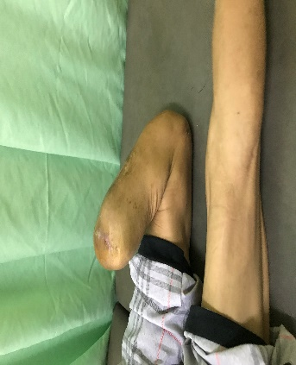

Figure 1. Right Residual Limb

Locally status (right residual limb)

Inspection: wound scar at anterior bottom (+), atrophy (+), bulbous stump shape with stitching at midline bottom, edema (-), ear dog (-), skin infection (-).

Palpation: pressure pain (-), movement pain (-), bony preminence (+) at the anterior stump, stump length 43,2% (standart BKA).

Muscle strength tested by using manual muscle testing (MMT) with result four for right lower extremity and five for left. Detailed measurement showed on table 1 and 2.

**Table 1. Range of Motion**

|  |  |  |
| --- | --- | --- |
|  | **Dextra** | **Sinistra** |
| **Hip**  Ext-Flexion  Abd-Adduction  Endo-Exorotation | 50°-0°-120°  60°-0°-40°  45°-0°-45° | 50°-0°-120°  60°-0°-40°  45°-0°-45° |
| **Knee**  Ext-Flexion | 0°-0°-130° | 0°-0°-130° |
| **Ankle**  Dorso-Plantar  Ev-Inversion | Amputee  Amputee | 30°-0°-50°  20°-0°-30° |

**Table 2. Antropometri Measurement**

|  |  |  |
| --- | --- | --- |
| **Examination**  Length | **Right** | **Left** |
| Medial tibial plateau – malleolus medialis  Medial tibial plateau - end of muscle  Mid patella – end of bone | Amputee  16 cm  14 cm | 37 cm  -  - |
| Thigh circumference | 35 cm | 38 cm |
| Calf circle | 30 cm | 33 cm |
| Sensibility  Propioseptif | Normal | Normal |
| Protopatic | Normal | Normal |
| Wound length | 8 cm | - |
| Stitching place | Middle of distal stump | - |

REHABILITATION COURSE

This patient had some rehabilitation problems, include: muscles weakness on right lower extremity; muscle atrophy on right leg (3 cm); phantom sensation; bulbous shape stump; limitation in vocational; also feels ashamed with her condition. We set goals from discussions with patient and her family also rehabilitation team. Short term goals for her: (1) prepare patient’s condition (pre-prosthetic training) to improve the muscle strength; (2) prepare the stump; (3) family and community counseling. Long term goals were: (1) she can ambulate properly with her prosthesis, and (2) can re-integrated to her community again.

Comprehensive rehabilitation management given for this patient, from preprosthetic training until check out prosthetic. Pre prosthetic training includes: strengthening exercise for all extremities, active range of motion exercise of right lower extremity, sensory re-education for stump, education of stump positioning to prevent contracture, shaping of the residual limb using elastic bandage, measuring and fitting for prosthetic limb after there is improvement on muscle strength and atrophy, give her mental support and family counseling, also home program education.

She was scheduled for evaluation every week, and on the third week, there was significant improvement for muscle strength and stump shape become more cylindrical. After she undergoes rehabilitation course to restore physical condition, muscle strength on right lower extremity, also stump shape and stump care, she got fitting and measurement for lower limb prosthesis and showed on figure 2.

Two weeks later the transtibial prosthetic was done and fit, so then we checked out for sitting, standing, walking position, and donning-doffing prosthetic. We also give her gait training using prosthetic (Figure 3). Home program were added about stump hygiene and prosthetic care.

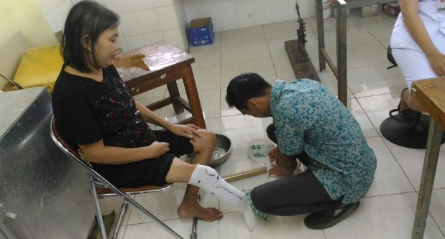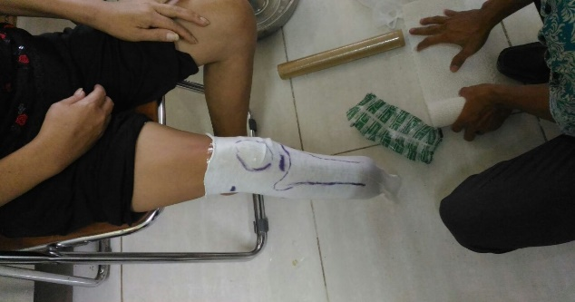

Figure 2. Fitting with cast.

DISCUSSION

This case report ilustrate the diverse rehabilitation challenge of transtibial prosthetic management after below knee amputation due to diabetic ulcer. Around 80% of acquired amputations on lower limb due to vascular disease (diabetes mellitus, peripheral vascular disease and chronic venous insuficiency) and diabetes contributes to two thirds of all lower limb amputations. Rehabilitation after the amputation should begin as soon as possible after surgery. The rehabilitation process of an amputee can be divided into pre-amputation, post-amputation/pre-prosthetic, prosthetic fitting and training, and long-term follow-up care. Patient in this case came to rehabilitation outpatient on post amputation or pre prosthetic phase with some problems: muscle weakness and atrophy on right lower limb, feel shame about her condition, and inproper shape of the stump. However, she has been accustomed to mobilizing and ambulation using bilateral axillary crutches.

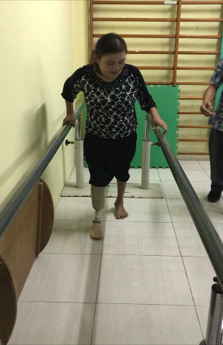

Figure 3.Gait training with transtibial prosthetic on

Goals of rehabilitation are to maximize the patient’s capabilities, function, and independence.14,15 For this patient, we have short term goals and long term goals. For short term goals, we plan she will get the prosthesis as soon as possible, give family and community councelling, give patient and his family support mental, pre-prosthetic training to improve the muscle strength and muscle mass, prosthetic training and gait training. For long-term goals, we hope she can re-integrated to her community again, and do her activity like before.

In this case, she came in the beginning of the second stage of prosthetic management. Post-amputation/ pre-prosthetics phase to promote wound healing and stump care, reduce edema, shape the limb to fit a prosthesis, and prevention of contractures.15 Reducing post-surgical edema is important to promote wound healing, minimize postoperative pain, and shape the limb for prosthetic fitting.15,16 Post-surgical edema stretches a surgical wound, which stretches nerve endings and causes pain.16 A variety of postsurgical dressing and edema control strategies are available, these include soft dressing, semirigid and rigid dressing applied in operating room.14 Elastic bandages can help control edema and remaining stump for prosthetic casting. A bandage of 4 inches (10 cm) is usually used for below knee stump.4,17 The stump should be bandage 24 hours/day except when bathing and re-bandaged every 4 - 6 hours and on loose, shifted or rolled bandage conditions.4,11,18

Rehabilitation course for this patient includes: build up a communication with the patient to gain good cooperation in order to achieve patient’s and medical team’s goals; preservation of upper body functions and unaffected lower limb; strengthening of upper body functions and unaffected lower limb; strengthening and ROM exercise for the amputee; elastic bandage for stump shaping. Those programs that have given to prepare the patient’s body to be able use the upcoming prosthesis. The patient must be prepared because the use of prosthesis will increased the energy expenditure. Therefore the stump length must be ideal to be fitted in the prosthesis. In transtibial amputation case, the ideal stump is about 5 – 6 inches, measured from the medial tibial plateau.18 If less than 6 inches, the stump end would be bulky (not sylindrical), lever arm for the prosthesis would also be short and increase the energy expenditure. If longer than 8 inches, ankle mechanism measurement would be interfered.20 In this case, functional stump length was 16 cm, then it is adequate to provide enough lever arm for the upcoming prosthesis and would not interfere the ankle mechanism measurement.

Exercises also should be implemented in this stage to prepare the patient for ambulation with the prosthesis. The goals of exercise are to maintain cardiovascular functions, to prevent any joint contracture, to promote wound healing at the stump site, to minimize pain and non-painful sensation after amputation.20 The ideal shape for transtibial amputation is cylindrical shape. The wound already healed, the pain and swelling also disappears. But we have some problem such as the muscle strength and muscle mass was not good, so we need to fix the problem first before we get into the prosthetic phase. Besides that, patient still collect the money to buy the prosthesis, so exercises using prosthesis is postponed. Thus, we give this patient education to shape his stump using elastic bandage while strengthening the muscles and waiting the fund from her children for prosthetic making. After bandaging with figure of eight, the stump shape getting better.

The next stage is Prosthetic fitting and Training. Prosthetics phase is given when the stump already stable. We can give prescription for permanent prosthesis working together with orthotic and prosthetic subunit. Stump stable means the wound has already healed, no pain and no swelling.18 Exercise start on paralel bar, standing and walking, sitting and standing, also going up and down the stairs with prosthesis on.21,22 Based on the patient’s need and medicare guidelines, we take the patient as amputee with K1 functional index. Then the next step while waiting for the prosthesis funding is discuss what the prosthesis would be constructed.

In prosthetics subunit, our goal is to fit the patient comfortably with the greatest return of function, and to make it look as natural as possible. To achieve this goal, we must create an appropriate socket (the part the residual limb fits into), and provide the best design ankle and foot to fit the patient’s life style requirements. In this patient, the wound had totally healed because the post amputation was about 3 months ago so we can immediate prepare the patient using total contact patellar tendon bearing socket (*Patellar Tendon Bearing* (PTB) supracondylar socket) with supracondylar suspension, endosceletal shank, and single axis foot.

On fitting time, we asked the patient to wear the prosthesis and asked if there are any discomfort while sitting, and standing. If there was no discomfort, then the patient was asked to ambulate with the prosthesis. Ambulation with the prosthesis may begin with:

1. First step: always begin with the unaffected limb.

2. Descending stairs: always descend with the prosthesis first.

3. Ascending stairs: always ascend with the unaffected limb.

Then we should inform the prosthesis wearing schedule because a new prosthesis may be comfortable for the first time use. Wearing for an excessive period of time increases the possibility of skin breakdown. Taking care of the stump and prosthesis are also very important and have to be done in a daily basis. The following are some guidance regarding residual limb and prosthesis maintenance:26

1. Wash the residual limb once a day. Rinse and dry completely to avoid soap residue.
2. Apply non-allergic moisturizer to keep the residual limb moisturized.
3. Wash the prosthesis once a day by using hand soap and damp cloth. The inside part of the socket should also be cleaned up because it may harbour bacteria build up. Be sure to rinse and dry completely to avoid soap residue.

4. Always use clean socks.

5. Maintain balanced diet to avoid body weight changes and keep doing the exercise at home.

This patient also given social medic support and psikolog to to give education about her condition and support the patient to follow all the rehabilitation programs. Mental support here was designed to support the patient in dealing with the condition she had. Hopefully, by this effort the patient’s anxiety would reduce and make this patient focus on her treatment.

In conclusion, this case report highlights the comprehensive rehabilitation management of BKA amputation. Preparation of prosthetic management ideally begin as soon as possible, before amputation surgery. Unfortunately, this patient begins rehabilitation program on second phase, pre prosthetic phase. But that is not significant obstacle because she had premorbid condition and her compliance was good. For further study, it is hoped that education and communication will be better for rehabilitation program so could begin as soon as possible, before amputation surgery.

REFERENCES

1. Cucurullo SJ. Physical Medical and Rehabilitation Board Review. 3rd ed. New York: Demos Medical; 2015. Chapter 6. Prosthetics and Orthotics; p.477-496
2. Engstrom B, Van de Ven C. Therapy for Amputees. 3rd ed. Philadelphia: Churchill Livingstone; 2005. Chapter 15, Trans-tibial level of amputation; p. 187-202.
3. Lusardi MM, Nielsen CC. Orthotics and Prosthetics in Rehabilitation. 2nd ed. Philadelphia: Saunders Elsevier; 2013. Chapter 23, Transtibial Prosthesis; p. 622-51.
4. Vitriana. Rehabilitasi Pasien Amputasi Bawah Lutut dengan menggunakan Immediate Post Operative Prosthetic. Jakarta: Universitas Indonesia; 2002.
5. Standard of Care: Lower Extremity Amputation. The Brigham and Women’s Hospital, Inc. 2011.
6. Lusardi MM, Nielsen CC, Milagros J. Orthotics and Prosthetics in Rehabilitation. 3nd ed. Philadelphia: Saunders Elsevier; 2013. Chapter 17, Etiology of Amputation; p.455-68.
7. Delisa JA, Gans BM, Walsh NE, Robinson LR. Delisa’s Physical Medicine & Rehabilitation Principles and Practice. 5th ed. Philadelphia: Lippincott William & Wilkins; 2010. Chapter 74, Upper and Lower Extremity Prosthetics; p. 2017-49.
8. Transtibial Prosthetics. A Patient Care Manual for The New Amputee (phamplet). Available from: [*http://oandp.health.usf.edu/Pt/transtib_pros/transtib_pros.pdf*](http://oandp.health.usf.edu/Pt/transtib_pros/transtib_pros.pdf)
9. A Manual for the Rehabilitation of People with Limb Amputation. USA: World Health Organization United States Department of Defense Moss Rehab Amputee Rehabilitation Program; 2004
10. Engstrom B, Van de Ven C. Therapy for Amputees. 3rd ed. Philadelphia: Churchill Livingstone; 2005. Chapter 1, Introduction; p. 1-9
11. Lusardi MM, Pepe JL. Orthotics and Prosthetics in Rehabilitation. 2nd ed. Philadelphia: Saunders Elsevier; 2013. Chapter 22, Amputation Surgeries for the Lower Limb; p.498-531
12. Brammer CM. Manual of Physical Medicine and Rehabilitation. Philadelphia: Hanley & Belfus inc; 2002. Chapter 1, Amputation Rehabilitation; p.1-12
13. Tan JC, Horn SE. Practical Manual of Physical Medicine and Rehabilitation. Missouri: Mosby; 1998. Chapter 4.4, Prosthesis; p. 229-59.
14. Lovegreen W, Murphy PD, Smith KW, Stevens P, Webster J. Lower limb amputation and gait. In: Cifu XD (editor). Braddom’s physical medicine and rehabilitation. 5th edition. Elsevier. Philadelphia. 2016; 10:191-223.
15. Weiss LD, Weiss JM, Pobre T. Oxford american handbook of physical medicine and rehabilitation. Oxford University Press. 2010;278-80.
16. Sage RA, Pinzur M, Stuck R, Napolitano C. Amputation and rehabilitation of the diabetic foot. In: Veves A, Giurini JM, Logerfo FW (editor). The diabetic foot 2nd edition. Humana Press Inc. New Jersey. 2006;368-86.
17. Fitzsimons T, Clark A, Symonds A, Navarrete M, Saad N, Lees P et al. Physiotherapy Following Lower Limb Amputation: Protocols and Reference Material. Western Cluster; 2006
18. Lusardi MM, Nielsen CC. Orthotics and Prosthetics in Rehabilitation. 2nd ed. Philadelphia: Saunders Elsevier; 2013. Chapter 20, Postoperative and Preprosthetic Care; p.532-94
19. Energy expenditure [Internet] [cited 2016 Sep 3]. Available from: http://www.encyclopedia.com/doc/1O39-energyexpenditure.html
20. Gailey RS. Energy Expenditure of Trans-Tibial Amputees During Ambulation. Prosthetics and Orthotics International; 2004. 18: 84-91.
21. Handoyo R. Rehabilitasi penderita diabetes mellitus dengan amputasi anggota gerak bawah. Simposium pengelolaan penderita cacat akibat diabetes mellitus. Semarang. 2001;1-11.
22. Hanspal R. Amputee and prosthetic rehabilitation, standards and guidelines. 2nd edition. British Society of Rehabilitation Medicine. 2003;1-79
23. Engstrom B, Van de Ven C. Therapy for Amputees. 3rd ed. Philadelphia: Churchill Livingstone; 2005. Chapter 4, Immediate postoperative treatment; p. 42-55
24. The immediate post surgical period. A manual for below knee amputation. (phamplet). Available from*:* [*http://www.oandp.com/resources/patientinfo/manuals/3.htm*](http://www.oandp.com/resources/patientinfo/manuals/3.htm)
25. Silverman A, Neptune R. Muscle and Prosthesis Contributions to Amputee Walking Mechanics. Journal of Biomechanics; 2012. 45: 2271–2278.
26. Maguire M. Prosthetic Rehabilitation Manual: Transtibial Amputation. American Journal of Physical Medicine & Rehabilitation; 2013. 69 (3): 511-523.