MEDICAL REHABILITATION IN PATIENT WITH AUTISM SPECTRUM DISORDER

¹Anne Maranu
¹Joudy Gessal

¹Physical and Rehabilitation Department of Sam Ratulangi University Manado
Email : anne.rannu@gmail.com, jgessal@yahoo.com

ABSTRACT: Autism spectrum disorder (ASD) is a neurodevelopmental disorder in which persons present with a range of impairments in social interaction, verbal and nonverbal communication, as well as restrictions in behaviors and interests. Additionally, the majority of the children with ASD may have significant perceptuo-motor impairments that deserve assessments and interventions.¹ Autism spectrum is estimated to affect about 1% of people (62.2 million globally as of 2015).² Males are diagnosed more often than females. The term "spectrum" can refer to the range of symptoms or their severity, leading some to favor a distinction between severely disabled autistics who cannot speak or look after themselves, and higher functioning autistics.³ There is no known cure for autism, although those with Asperger syndrome and those who have autism and require little-to-no support are more likely to experience a lessening of symptoms over time. The main goals of treatment are to lessen associated deficits and family distress, and to increase quality of life and functional independence.⁸ We report the rehabilitative course of 3 years and 4 month old boy, who came to the PMR department brought by his parents with chief complaint cannot communicate and have limited eye contact with people
Key Words: autism spectrum disorder, neurodevelopmental disorder, asperger syndrome

ABSTRAK: Gangguan spektrum autism (ASD) adalah gangguan perkembangan saraf di mana terdapat berbagai gangguan dalam interaksi sosial, komunikasi verbal dan nonverbal,serta keterbatasan dalam perilaku dan minat. Selain itu, sebagian besar anak-anak dengan ASD kemungkinan besar memiliki gangguan persepsi motorik yang signifikan yang memerlukan penilaian dan intervensi. Spektrum autisme diperkirakan mempengaruhi sekitar 1% orang (62,2 juta secara global pada 2015). Laki-laki didiagnosis lebih sering daripada perempuan. Istilah “spektrum” dapat merujuk pada rentang gejala atau tingkat keparahannya, yang menunjukan perbedaan antara autis dengan gejala berat yang tidak dapat berbicara atau merawat diri sendiri, dan autistik ringan yang berfungsi lebih tinggi. Belum ditemukan adanya pengobatan untuk autism. Autisme ringan atau sindrom Asperger adalah mereka yang hanya memerlukan sedikit bantuan atau dukungan dan cenderung mengalami pengurangan gejala dari waktu ke waktu. Tujuan utama pengobatan adalah untuk mengurangi keterbatasan dan untuk meningkatkan kualitas hidup dan kemandirian fungsional. Kami melaporkan perjalanan rehabilitasi anak laki-laki berusia 3 tahun 4 bulan, yang datang ke departemen rehabilitasi medik dibawa oleh orang tuanya dengan keluhan utama tidak dapat berkomunikasi dan memiliki kontak mata yang terbatas dengan orang
Kata kunci: sindroma autisma, gangguan perkembanga syaraf, sindrom asperger

INTRODUCTION
Autism spectrum disorder (ASD) are a neurodevelopmental disorder in which persons present with a range of impairments in social interaction, verbal and nonverbal communication, as well as restrictions in behaviors and interests. Additionally, the majority of the children with ASD may have significant perceptuo-motor impairments that deserve assessments and interventions.¹
Autism spectrum is estimated to affect about 1% of people (62.2 million globally as of 2015).² Males are diagnosed more often than females. The term "spectrum" can refer to the range of symptoms or their severity, leading some to favor a distinction between severely disabled autistics who cannot speak or look after themselves, and higher functioning autistics.³
The neuropathology of autism begins during the prenatal or perinatal period of

development. Although there is no clear etiology, twin studies point to genetics as one of the risk factors. Twin studies have shown that among identical twins, the occurrence of ASD in one child increases the chance of the other having ASD by 36% to 95%.⁴ Among siblings, if one child has ASD, then the other child has a 31% risk of developing ASD. Furthermore, siblings of children with ASDs are reported to have a 25% to 50% risk of developing other developmental delays that warrant intervention, for example, social, language, sensory, or motor delays or abnormalities. For this reason, researchers often conduct a prospective follow-up of infant siblings of children with ASDs to understand the early development of infants at risk for ASDs.⁵ Other populations at risk for developing ASDs include infants who were born prematurely,were born to older parents, or who were exposed to prescription medications such as valproic acid and thalidomide during gestation.⁶

In the United States, a revision to autism spectrum disorder (ASD) was presented in the Diagnostic and Statistical Manual of Mental Disorders version 5 (DSM-5), released May 2013. The new diagnosis encompasses previous diagnoses of autistic disorder, Asperger syndrome, childhood disintegrative disorder, and pervasive developmental disorders–not otherwise specified (PDD-NOS). Compared with the DSM-IV diagnosis of autistic disorder, the DSM-5 diagnosis of ASD no longer includes communication as a separate criterion, and has merged social interaction and communication into one category. Another change to the DSM includes collapsing social and communication deficits into one domain. Thus, an individual with an ASD diagnosis will be described in terms of severity of social communication symptoms, severity of fixated or restricted behaviors or interests, and associated features. The restricting of onset age has also been loosened from 3 years of age to "early developmental period", with a note that symptoms may manifest later when social demands exceed capabilities.⁷ There is no known cure for autism, although those with Asperger syndrome and those who have autism and require little-to-no support are more likely to experience a lessening of symptoms over time. The main goals of treatment are to lessen associated deficits and family distress, and to increase quality of life and functional independence.⁸ It has been argued that no single treatment is best and treatment is typically tailored to the child's needs. Treatment efforts are generally individualized, and can include behavioural therapy, and the teaching of coping skills. The most essential role is also to assess and target the child’s sensory processing disorder

CASE REPORT
INITIAL PRESENTATION
A 3 years and 4 month old boy came to the PMR department on April 4th 2019. Patient was brought by his parents with chief complaint cannot communicate and have limited eye contact with people. He seems like ignoring people. This patient was hyperactive and also showed repetition gesture like when he’s happy he will flapped her hand. He also has several uncommon behavior like eating paper, toilet paper, sucking telon oil and often stimulated his lips by playing with his lips. He also plays alone and only plays on specific toys. Patient’s parents also complain that he has drooling and only wanted to eat soft textured food like porridge.
On physical examination, his weight was 11kg dan height 85 cm (normal according to WHO growth chart). Patient looked active with his awareness was compos mentis. General status within normal limit. Denver II examination found there’s delayed on all four criteria (personal social, fine motor, language and gross motor). M-CHAT-R found high risk for autism spectrum disorder and from sensory short profile showed there were problems in tactile sensitivity, taste/smell sensitivity, seek sensation and auditory filtering. From bera test showed there was no hearing problem.

Diagnosis
In medical diagnosis, the clinical diagnosis is Autism Spectrum Disorder (F. 84.0), the Topical diagnosis: Cerebral Cortex (Primary Sensory Area). Etiological diagnosis is prematurity. Sensory Processing Problem that found mainly in tactile sensitivity, taste/smell sensitivity, seeks sensation, auditory filtering, movement sensitivity, inattention, inadequate postural control, and delayed speech.
The short term goal for management of this patients are to improve parental understanding about condition of the patients, improve attention/focus, improve fine and gross motor function, improve taste sensitivity (swallowing textured food), improve tactile sensitivity, and improve movement sensitivity. Whereas the long term goal for this patients are to improve capability in playing, learning, and carrying out daily routine and self care, and integration insot social community (preparing for school).

Rehabilitation Treatment Plan
Sensory Integration Therapy:
1.Therapy for tactil and proprioceptive hypersensitivity (Wilbarger protocol)
2.Postural control and strengthening core muscles
3.Therapy for vestibular and proprioceptive hypersensitivity
4.Sensory diet for touch
5.Movement and oral-motor
6.Playing activities to improve attention/focus
7.Fine and gross motor activity

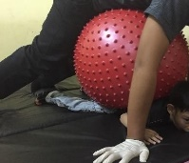
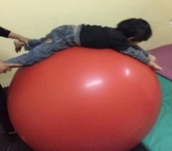

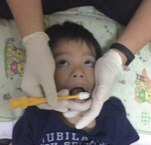

Strengthening core muscles, deep pressure with therapy ball, oromotor stimulation
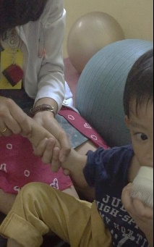
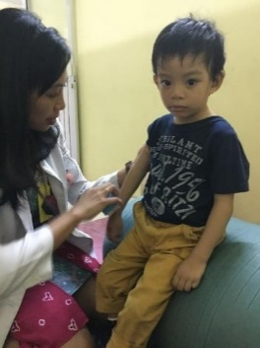

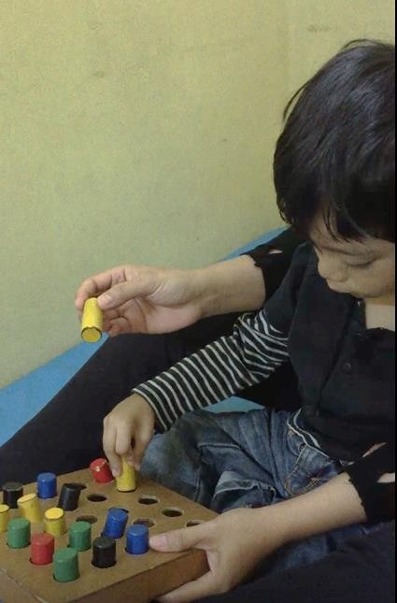

Fine and gross motor activity, Wilbarger protocol (brushing and joint compression)

Speech Therapy
1. Stimulation for non verbal communication, using pictures communication and
the parents have to learn what the meaning of gesture from their children in every picture
2. Oromotor stimulation
3. Have conversation with child as many as possible,
4. Communicate everything in simple words,
5. Speak to child in his eye level
6. Evaluate psychologic status of the parents and give mental support.
7. Identifies family needs and refers family to formal and informal support agencie s and organizations.

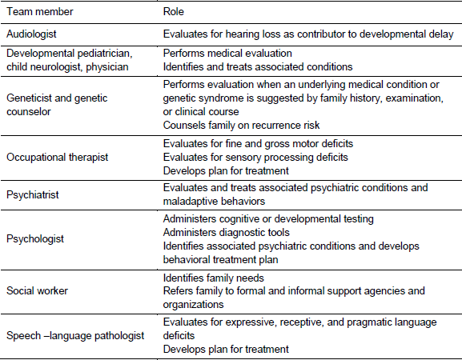

DISCUSSION
Autism spectrum disorders (ASDs) is a complex neurodevelopmental disorder characterized by severe impairments in social communication and social interaction and a range of restricted, repetitive patterns of behaviors, interests, or activities.¹
Autism prevalence was reported to be 1:303 and 1:94 in 14 places in the US, with an average 1:150 or 6.6 in every 1,000 children aged 8 years in 2007. According to the Autism and Developmental Disabilities Monitoring Network (ADDM), the prevalence of autistic spectrum disorder in children was 16.8 per 1000 in 2014, an absolute increase of 2.2% since 2012 and more than double the prevalence in 2000 when monitoring by the ADDM began.⁴ Indonesia does not have exact data on ASD prevalence, but the number of children diagnosed with ASDs is increasing. Rising autism rates are likely to be driven by better awareness and detection among minority ethnic groups. Prevalence of autism was four times greater in boys than in girls (26.6 vs 6.6 per 1000.⁴
The etiology of autism is poorly understood. ASD is multifactorial disease, and both genetic and environmental factors are believed to account for its development. A recent study reported that 35% to 40% of autism could be explained by the genetic factors.⁵ The remaining 60% to 65% are likely to be resulted from other factors, such as prenatal, perinatal, and postnatal environmental factors (Table 1).^{6,7,8} Other populations at risk for developing ASDs include infants who were born prematurely,were born to older parents, or who were exposed to prescription medications such as valproic acid and thalidomide during gestation.⁶
Key diagnostic features of children with ASD include deficits in social communication and restricted, repetitive patterns of behavior, interest, or activities. In many cases, a reliable diagnosis can be made by 24 months of age.¹⁰ Social deficits and delays in spoken language are the most prominent 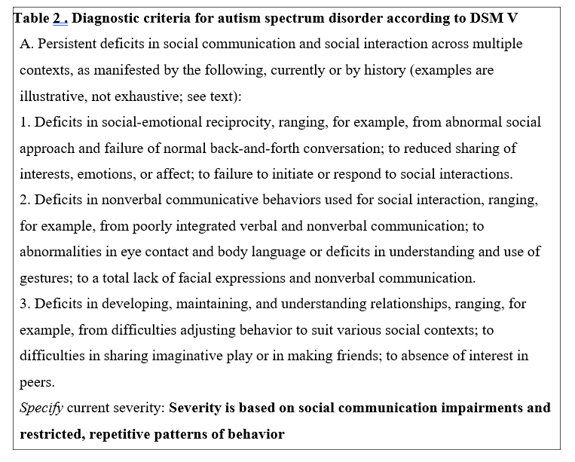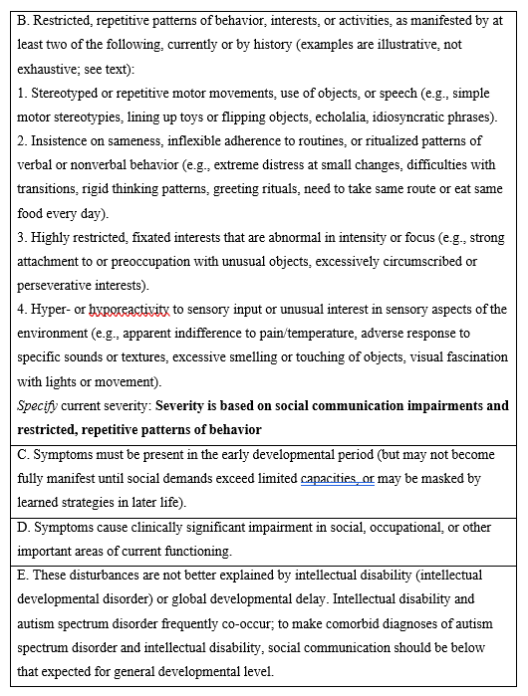
features in children younger than three years. Joint attention is the ability to coordinate one’s own attention between another person and a distant object to share interest. Neurotypical children respond to joint attention at 12 months of age and initiate it by 14 months of age. Those who is not demonstrating
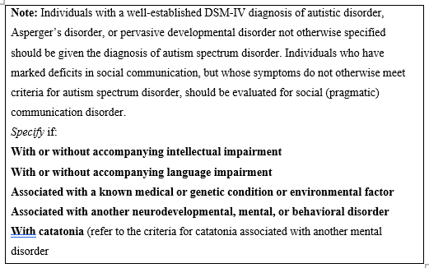joint attention after 15 months of age should be evaluated for ASD. Parents may present with a concern for hearing loss because children with ASD may not respond after multiple attempts to get their attention by calling their name.¹¹⁻¹³
Delayed language development should raise concerns. Language delay at 18 to 24 months of age without compensatory pointing or gesturing may help differentiate between ASD and expressive language delay. Echolalia used as the only language in a child older than 24 months is associated with ASD.¹²⁻¹³
Formal screening with an ASD specific screening instrument is recommended by the American Academy of Pediatrics (AAP) for all children at the 18- and 24-month visits because implementation of ASD screening lowers the age of ASD diagnosis and entry into appropriate therapy.² Screening tools help identify children who may need a more thorough diagnostic assessment. Formal screening is more effective than relying on clinical judgment alone.¹⁴ However, there are no randomized clinical trials assessing the effectiveness of screening for ASD in children three years or younger based on long-term outcomes. The American Academy of Family Physicians and the U.S. Preventive Services Task Force found insufficient evidence to make a recommendation for screening in children 18 to 30 months of age in whom no concerns of ASD are suspected.¹⁵⁻¹⁶ Routine developmental screening is suggested at nine-, 18-, and 24- or 30-month well-child visits.¹⁷⁻¹⁸
The American Academy of Pediatrics recommends targeted screening for ASD with a validated screening tool at 18 and 24 months of age for early identification.^{2,17} The Modified Checklist for Autism in Toddlers (M-CHAT) is the most widely used screening tool. However, when used alone, it has poor positive predictive value and a high false-positive rate. The authors of that tool have since published the Modified Checklist for Autism in Toddlers–Revised, with Follow-Up (M- CHAT-R/F).21 The M-CHAT-R/F is a two-stage parent-reported screening tool to assess the risk of ASD. A positive screening test result or parental concerns at any age should be followed by a structured interview and, if indicated, a referral for diagnostic assessment.^{2,17} This patient was tested using M-CHAT-R and he got total score of 14 which is high risk of suffered from ASD therefore according to the result this patient was referred immediately for early intervention and diagnostic evaluation. The evaluation aims to definitively diagnose ASD, exclude conditions that mimic ASD, identify comorbid conditions, and determine the child’s level of functioning. In the absence of a team, an individual clinician with expertise in evaluasting ASD (e.g child osychologist, developmental pediatrician) is appropriate. The evaluation should include a complet history and direct assessment of social communication skills and restricted, repetitive behaviors with standardized testing of language and cognitive skills. The diagnosis must be confirmed using the DSM-5 criteria for ASD (Table 2).
Symptoms that this patient experienced were similar with criteria for ASD according to DSM-5 criteria where the patient experienced persistent deficits in social communication and social interaction , stereotyped or repetitive motor movements, use of objects, hyper-reactivity to sensory input or unusual interest in sensory aspects of the environment and was present in the early developmental period (his parents realized his symptoms when he was 18 months of age). This symptoms that this patient experienced make him had impairment in social, occupational, or other important areas of current functioning. He cannot play with children of his age and he cannot carrying out daily routines that other children of his age are capable to do like changing clothes or as simple as washing hand
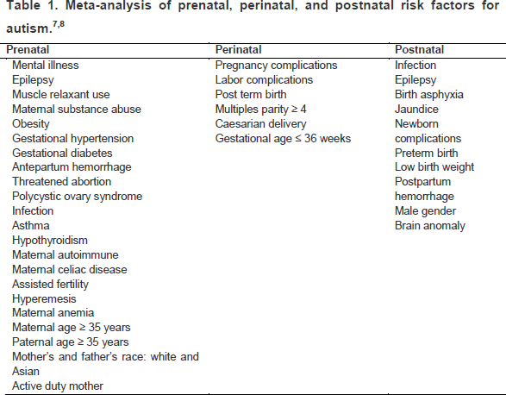
Evaluation for ASD should include a comprehensive assessment, preferably by an interdisciplinary team (Table 1). This patient were brought by his parents to check his hearing because of his communication problem and the result was no hearing problem and was consulted to growth and development clinic and physical medicine and rehabilitation clinic for speech and behavioral therapy.
Sensory processing disorder (SPD) management guidelines for ASD vary widely and there has been no systematic assessment or therapy in the form of a protocol. Therapy is individualized (tailored made) which means that it is adjusted to the age, type of sensory disorder, growth and development status, choice and variation of children's activities and responses.⁸⁻⁹
Playing as a medium of sensory integration therapy. Playing especially for children is an activity that is done automatically. By playing children will develop their knowledge and interact with the world around them. Playing can be used as a therapeutic medium. Playing activities are used in two ways namely as a method of therapy and therapeutic modality.⁸⁻⁹ In sensory integration therapy, children must feel safe from physical and psychological treatment, including coercion. In interventions based on sensory integration principles, children use sensorimotor skills to interact with the environment that were specifically designed to provide opportunities to enhance the existing sensations. This will continue to be repeated until the child becomes proficient.⁸⁻⁹
Therapy begins with activities that are in accordance with competence and provides comfort for the child and then the activity is gradually increased according to the conditions and response of the child, up to maximum involvement in the activity.⁸⁻⁹ Sensory integration therapy also requires adequate facilities as an important aspect of intervention. The tools are grouped into 4 namely: Tactile equipment (tactile sensory gloves, brush, sensory balls, vibrator), Non-suspended moving equipment (trampoline, therapy balls, rocking board), Hanging equipment (hammock, bolster, swinging, sliding board), Motor planning equipment
There are several development intervention based on sensory integration principles such as Wilbarger protocol for tactil and proprioceptive hypersensitivity and clinical application of sensory diet that include several aspects of sensory inputs such as : vision, sound, touch, movement and oral-motor.⁸⁻⁹
Prior to sensory integration therapy, identification of target of sensory must be done. Sensory short profile is one of the most common tools to identify sensory disorder in ASD children. The Sensory Profile is a measure of children's responses to sensory events in daily life. It provides an overall picture of a child's sensory processing patterns. Results of the sensory profile are used to consider how these patterns might be contributing to or creating barriers to a child's performance in daily life. The Short Sensory Profile (SSP) is a 38-item caregiver questionnaire and score sheet designed for use in screening and research protocols. According to SSP screening tools this patient has problems in tactile sensitivity, taste/smell sensitivity, seek sensation and auditory filtering.⁹
Therapy that were given to this patient were based on anamnesis and physical examination and also from the result of SSP test. This patient were given sensory integration therapy, speech therapy and mental and social supports for his parents. Sensory integration therapy for this patient include therapy for tactil and proprioceptive hypersensitivity (Wilbarger protocol), postural control and strengthening core muscles, therapy for vestibular and proprioceptive hypersensitivity, sensory diet for touch, movement and oral-motor, playing activities to improve attention/focus, fine and gross motor activity . Speech therapy that was given for this patient were stimulation for non verbal communication, using pictures communication and the parents have to learn what the meaning of gesture from their children in every picture, oromotor stimulation, and encourage the parents to have conversation with child as many as possible, communicate everything in simple words, speak to child in his eye level.
After seven months of therapy, this patient showed several progression according to his parents that this patient is now more calm than before therapy and have eye contact though still minimal but this patient can focus on several task so his parents found it easier now to take care of him like teaching him how to brush his teeth or clothing him is now easier.
The prognosis of this patient, ad vitam is ad bonam because there is no complications that could be life-threatening. Ad functionam is dubia ad bonam because the therapy was done early when this patient still 3 years 4 month old when brain plasticity is going on but we cannot predict the continuation of therapy in this patient in the upcoming years. His parents compliance and treatment attendance will affect the outcome. Now patient have a routine medical rehabilitation. Location of the house is not too far from the hospital and his parents already trained to give simple exercise at home. Besides that family had middle socio-economic status and they used insurance financial (BPJS) to care the patient, so he can get fully supported from his parents and families. Ad sanationam is ad malam because the course of autism is stable until adulthood and only some ability will improve with the right therapy.
Physical and psychological stimulation, as well as care and affection, are necessary in order to improve outcome. Successful management of this patient requires that both medical and social problems be recognized and corrected. His future conditions depend on adequate and sustainable management of regular medical rehabilitation, constant stimulation, and also love and care of the parents.

REFERENCES
- Chawarska K, Macari S, Volkmar FR, Kim SH, Shic F. ASD in infants and toddlers. In Volkmar FR, Rogers SJ, Paul R, Pelphrey KA, editors. Handbook of Autism and Pervasive Developmental Disorders. 4th ed. New Jersey: John Wiley & Sons; 2014.p.121-38.
- Baio J, Wiggins L, Christensen DL, Maenner MJ, Daniels J, Warren Z, et al. Prevalence of autism spectrum disorder among children aged 8 years-Autism and developmental disabilities monitoring network, 11 sites, United States. Centers for Disease Control and Prevention Surveillance Summaries. 2018;67:1-23.
- Sanchack KE, Thomas CA. Autism Spectrum Disorder: Primary Care Principles. Am Fam Physician. 2016;94:972-79.
- Hallmayer J, Cleveland S, Torres A, et al. Genetic heritability and shared environmental factors among twin pairs with autism. Arch Gen Psychiatry 2011;68:1095–102.
- Tchaconas A, Adesman A. Autism spectrum disorders: a pediatric overview and update. Curr Opin Pediatr 2013;25:130–44.
- Wang C, Geng H, Liu W, Zhang G. Prenatal, perinatal, and postnatal factors associated with autism. Medicine. 2017;96:1-7.
- American Psychiatric Association. Diagnostic and Statistical Manual of Mental Disorders. 5th ed. Washington, DC: American Psychiatric Association; 2013:50-51.
- Luh Kurniawan. Pemrosesan Sensori Sebagai Fondasi Perkembangan Anak. PERDOSRI. Jakarta. 2014.
- Luh Kurniawan. Sensory Processing Disorder. Readoctopus. Jakarta. 2019.
- Guthrie W, Swineford LB, Nottke C, Wetherby AM. Early diagnosis of autism spectrum disorder:stability and change in clinical diagnosis and symptom presentation. J Child Psychol Psychiatry. 2013;54:582-90
- Carbone PS, Farley M, Davis T. Primary care for children with autism. Am Fam Physician. 2010;81:456.
- Blenner S, Reddy A, Augustyn M. Diagnosis and management of autism in childhood. BMJ. 2011;343:894-99.
- Baird G, Douglas HR, Murphy MS. Recognising and diagnosing autism in children and young people: summary of NICE guidance. BMJ. 2011;343:1-3.
- American Psychiatric Association. Diagnostic and Statistical Manual of Mental Disorders. 5th ed. Washington, DC: American Psychiatric Association; 2013:50-51.
- Miller JS, Gabrielsen T, Villalobos M, Alleman R, Wahmhoff N, Carbone PS, et al. The each child study: systematic screening for autism spectrum disorders in a pediatric setting. Pediatrics. 2011; 127: 866-71.
- American Academy of Family Physicians. Clinical Preventive Service Recommendation. Autism spectrum: children (aged 18 to 30 months). (http://www.aafp.org/patient-care /clinical-recommendations/all / autism- children.html, Accessed October 15, 2018)
- 17. Siu AL, Bibbins-Domingo K, Grossman DC, Baumann LC, Davidson KW, Ebell M, et al. Screening for autism spectrum disorder in young children: US Preventive Services Task Force recommendation statement. JAMA. 2016; 315: 691-

