MEDICAL REHABILITATION IN PATIENT WITH LEFT HEMIPARESIS AND DYSARTHRIA CAUSED BY TRAUMATIC BRAIN INJURY: A CASE REPORT

¹Anne Marranu
¹Lidwina Sengkey

¹Physical and Rehabilitation Departement of Sam Ratulangi University Manado
Email : anne.ranu@gmail.com, lidwinasimasengkey@yahoo.com

ABSTRACT: Traumatic brain injury (TBI) is an insult to the brain from an external physical force and resulting in temporary or permanent impairment, functional disability, or psychosocial maladjustment.¹ TBI occurs twice as frequently in males as in females with rasio 2.5: 1 and mortality in males is three to four times higher than in females. ^{1,2} The incidence of TBI peaks among those 15 to 24 years old and again among those 65 years and older, Motor vehicle accidents and violence are more common in a younger population, and falls are more common in aging populations.^{3,4}. While based on the severity of TBI can be divided into mild, moderate, and severe head injury. The commonly used scale is the Glasgow Coma Scale (GCS). Head injuries with GCS 13-15 were categorized as mild head injury, head injury with GCS 9-12 was categorized as moderate head injury, and head injury with GCS 3-8 was categorized as severe head injury. ^{5,6} Hemiparesis is weakness or partial paralysis on one side of the body caused by brain damage, usually opposite the site of the cerebral vascular accident (CVA) or other brain injury. Patients with traumatic brain injury may have difficulty with mobility and self-care as a result of isolated motor weakness or coordination of either the upper or the lower extremities.⁷ Dysarthria, a group of motor speech disorders resulting from damage to the central or the peripheral nervous system, affects 10% to 65% of individuals with acquired brain injury, depending on the type, extent, and duration of injury. Dysarthria results from weakness, paralysis, or dyscoordination of the speech muscles that impairs articulation, respiration, resonance, and phonation. Rehabilitation includes four function domains; physical, mental, affective, and social. Thus, rehabilitation services organized with multiprofessional teams are required to guide treatment planning and to promote the approach of all these aspects.⁸ We report the rehabilitative course in young man with left hemiparesis and dysarthria caused by traumatic brain injury.

Key Words: Traumatic Brain Injury, Hemiparesis, Dysarthria

ABSTRAK: Cedera otak traumatik adalah gangguan pada otak dari gaya fisik eksternal dan mengakibatkan kerusakan sementara atau permanen, cacat fungsional, atau gangguan psikososial.¹ TBI terjadi dua kali lebih sering pada laki-laki dibandingkan pada perempuan dengan rasio 2.5:1 dan mortalitas pada laki-laki tiga sampai empat kali lebih tinggi daripada perempuan. ^{1,2} Insiden puncak TBI di antara mereka yang berusia 15 hingga 24 tahun dan juga di antara mereka yang berusia 65 tahun ke atas. Kecelakaan kendaraan bermotor lebih sering terjadi pada populasi yang lebih muda, dan jatuh lebih sering terjadi pada populasi lansia.^{3,4}. Sedangkan berdasarkan beratnya TBI dapat dibedakan menjadi cedera kepala ringan, sedang, dan berat. Skala yang biasa digunakan adalah Glasgow Coma Scale (GCS). Cedera kepala dengan GCS 13-15 dikategorikan cedera kepala ringan, cedera kepala dengan GCS 9-12 dikategorikan cedera kepala sedang, dan cedera kepala dengan GCS 3-8 dikategorikan cedera kepala berat. ^{5,6} Hemiparesis adalah kelemahan atau kelumpuhan parsial pada salah satu sisi tubuh yang disebabkan oleh kerusakan otak, biasanya berlawanan sisi dengan lokasi gangguan pembuluh darah otak (CVA) atau cedera otak lainnya. Pasien dengan cedera otak traumatis mungkin mengalami kesulitan dengan mobilitas dan perawatan diri sebagai akibat dari kelemahan motorik atau kesulitan koordinasi ekstremitas atas atau bawah.⁷ Disartria, sekelompok gangguan bicara motorik akibat kerusakan pada sistem saraf pusat atau perifer, mempengaruhi 10% hingga 65% individu dengan cedera otak didapat, tergantung pada jenis, luas, dan durasi cedera. Disartria terjadi akibat kelemahan, kelumpuhan, atau diskoordinasi otot-otot bicara yang mengganggu artikulasi, respirasi, resonansi, dan fonasi. Rehabilitasi mencakup empat domain fungsi; fisik, mental, afektif, dan sosial. Dengan demikian, layanan rehabilitasi yang diselenggarakan dengan tim multiprofesional diperlukan untuk memandu perencanaan perawatan dan untuk mempromosikan pendekatan semua aspek ini.⁸ Kami melaporkan tatalaksana rehabilitatif pada pria muda dengan hemiparesis kiri dan disartria yang disebabkan oleh cedera otak traumatis.

Kata kunci: Cedera otak traumatic, hemiparesis, disartria

Introduction
TBI occurs twice as frequently in males as in females with rasio 2.5: 1 and mortality in males is three to four times higher than in females. ^{1,2} Motor vehicle accidents and violence are more common in a younger population, and falls are more common in aging populations.^{3,4} Symptoms may vary according to the severity of the injury and the stage of recovery. The patient’s history should include a detailed summary of the mechanism of injury, comorbid conditions, initial Glasgow Coma Scale score, length of the coma (if any), and length of post-traumatic amnesia. Patients with severe injury and dramatically altered levels of arousal often can offer no subjective symptoms. After the acute phase of recovery, the clinician can expect symptoms to include seizures, contractures, spasticity, altered vision, vertigo or dizziness, and altered sense of smell.⁷ Such brain injuries caused by TBI can result in physical deficits such as plegia that can involve the limbs, tone alteration, ataxia, sensory disorders, and impaired postural control. They can also cause speech disorders; cognitive deficit that lead to attention and concentration alterations, learning disabilities, objects recognition, and spatial relations disorder; also behavioral deficits such as emotional lability, aggressiveness, impulsiveness, disorientation, agitation, irritability, low frustration threshold, and sexual disinhibition^{.8} Hemiparesis is weakness or partial paralysis on one side of the body caused by brain damage, usually opposite the site of the cerebral vascular accident (CVA) or other brain injury. Patients with traumatic brain injury may have difficulty with mobility and self-care as a result of isolated motor weakness or coordination of either the upper or the lower extremities.⁷ Spasticity is a common problem among patients with brain injury. It is estimated to affect as much as 80% of the traumatic brain injury population.⁹
Dysarthria, a group of motor speech disorders resulting from damage to the central or the peripheral nervous system, affects 10% to 65% of individuals with acquired brain injury, depending on the type, extent, and duration of injury. Dysarthria results from weakness, paralysis, or dyscoordination of the speech muscles that impairs articulation, respiration, resonance, and phonation (voice production). Dysarthria is divided into subtypes according to the speech characteristic and underlying pathophysiologic process. Unilateral UMN dysarthria (UUMND) which is commonly seen in patients with stroke, tumor or head trauma where only inappropriate articulation occurs due to facial and lingual nerve deficiency which is the main characteristic. Motor-sensory disturbances usually mild and temporary.^{10,11,12}
Rehabilitation includes four function domains; physical, mental, affective, and social. Physical function refers to sensorimotor skills required in the performance of activities of daily life and instrumental activities, which are advanced skills and considered vital for the individual’s independence within the community. Mental function is related to the individual’s intellectual and cognitive capabilities; the affective function regards affective capabilities and coping strategies in dealing with problems and difficulties, and lastly, social function refers to the ability to interact with other people in a successful manner, to the performance of social roles and obligations. Thus, rehabilitation services organized with multi-professional teams are required to guide treatment planning and to promote the approach of all these aspects.⁸

CASE REPORT
Initial Presentation
A 22 year old man, freelancer, was hospitalized in F ward, treated by Neurology Department with Impaired consciousness due to brain subdural hematoma 5 weeks ago. Patient was on his way home after dropping his costumer then suddenly his motorbike was hit by a man and he was suddenly pressed the brake and was thrown away and his head hit the stone (patient didn’t use helmet). He suddenly threw up then he managed to stand up but fell off to the ground and after that he couldn’t remember what was happened. He was found unconsciousness right after the accident and was in unconsciousness state for 15 days. Right after the accident he was hospitalized in AURI hospital then referred to RSUP Prof DR R.D. Kandou Manado and was treated for 3 days in ICU then transferred to F ward with total 24 days of hospitalization. When he already conscious, only his son that he could recognize but he needs only a day to fully remember the accident and remember all of his family member (person), place and time. Patient now has difficulty in mobilization, transfer and ambulation. He couldn’t sit independently, he couldn’t stand alone and also he couldn’t walk. He just lay down in bed. He needs assistant in doing almost all daily activities. He also has problem in communication (slurred speech) that he has difficulty pronouncing words that has the letter “r”.
On admission, he was alert, his vital sign within normal limit, dependent on ambulation and noticeably left handed person. He has no problems at general examination. On physiatric examination findings there are slight paresis on his 7th and 12th right cranial cranial nerve (picture 1 and 2), increased deep tendon reflexes on his right extremities, spasticity on his right upper and lower extremity with ashworth scale of 1 and 2 respectively, positive Babinski reflex on his right foot. Result of Manual Muscle Testing (MMT) examination and other examination are shown in the table below.
Patient is totally dependent when doing his daily living activities as he only scores 20 out of 100 on Barthel Index assessment. Patient has normal cognitive function and no other problem at the examination of language modalities such as fluency, repetition, comprehension, writing, reading and naming despite his difficulty saying a word, and we concluded this patient has dysarthria. Lastly, patient has disturbance in his static and dynamic balance.
This patient has several rehabilitation problems, include: Balance disturbance sitting and standing, limitation of ADL (feeding,bathing, dressing and ambulation), voice articulation disorder, with sound distortion for consonant (r), worried and feel ashamed because of his illness, low financial status, weakness of left upper and lower extremity muscles, spasticity of left upper extremity, limitation of left hand function. We set short and long-term goals based on our discussion with the patient himself and his family, our short term goals are: (1) Improve muscle strength of the weak left extremity muscles (2) Decrease/prevent increasing of spasticity (3) Improve voice articulation (4) Correction of current deformities, and our long-term goals are: (1)Prevent secondary impairment, such as contracture and deformities (2)Improve independency of ADL (3)Improve integration and participation to the community (4) Improve quality of life.
Comprehensive rehabilitative management is given to this patient, which included physical therapy, occupational therapy, speech therapy, psychologic counseling, and social medic intervention.

Table 1. Physiatric examination result on patient

 | Upper extremity Lower extremity
 | Right Left | Right Left
Move-  ment | Normal Decreased | Normal Decreased
Muscle Power | 5/5/5/5 1/1/1/1 | 5/5/5/5 0/0/0/0
Muscle Tone | Normal Increased | Normal Increased
Physiological reflex | ++ +++ | ++ +++
Patologic Reflex | - - | - +  (Babinski)

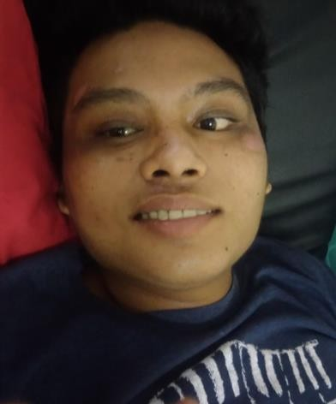

Picture 1. Slight Paresis on 7th Cranial Nerve

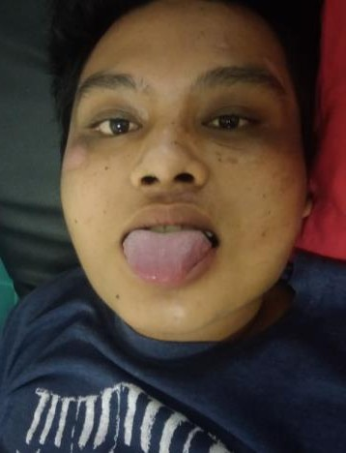
Picture 2. Slight paresis on 12th Cranial Nerve

He was scheduled for evaluation every month, there was significant improvement on his left extremity muscle strength, improved sitting and standing balance, increased Barthel index in every evaluation (20 to 85) although the spasticity and clonus did noy show any improvement at all until the end of evaluation.

Discussion
In this case report, we discuss about a 22 years old male patient who was diagnosed with left hemiparesis and dysartria caused by traumatic brain injury (TBI). The diagnosis was constructed by anamnesis, physical examination and supporting examination (CT- Scan). From anamnesis of the patient we found weakness of left extremity since 33 days ago (August 17th 2017) after the patient got motorbike accident. Right after the accident he was hospitalized in AURI hospital then referred to RSUP Prof DR R.D. Kandou Manado and was treated for 3 days in ICU then transferred to F ward with total 24 days of hospitalization. When he already conscious, only his son that he could recognize but he needs only a day to fully remember the accident and remember all of his family member (person), place and time. Patient now has difficulty in mobilization, transfer and ambulation. He could not sit independently, he could not stand alone and so does walking. He just lay down in bed. He needs assistant in doing almost all daily activities. He also has problem in communication (slurred speech) that he has difficulty pronouncing words that has the letter “r”. These symptoms that patient had were corresponds to the definition of traumatic brain injury that is traumatic brain injury (TBI) is an insult to the brain from an external physical force and resulting in temporary or permanent impairment, functional disability, or psychosocial maladjustment¹.
Such brain injuries caused by TBI can result in physical deficits such as plegia that can involve the limbs, tone alteration, ataxia, sensory disorders, and impaired postural control. They can also cause speech disorders; cognitive deficit that lead to attention and concentration alterations, learning disabilities, objects recognition, and spatial relations disorder; also behavioral deficits such as emotional lability, aggressiveness, impulsiveness, disorientation, agitation, irritability, low frustration threshold and sexual disinhibition.⁸ . This patient has post traumatic amnesia, cognitive impairment, attention disorder, communication disorder and weakness of his left extremity as a consequence following his traumatic brain injury.
From physical examination we found this patient is alert with GCS 15, weakness of left extremity with muscle strength for upper extremity is 1/1/1/1 and lower extremity is 0/0/0/0 and also there is increased of muscle tone in left extremity with modified asworth scale for upper extremity is 1 and for lower extremity is 2. On this patient we also found there is increasing in physiological reflex and there is pathological reflex on left lower extremity (babinski) and we also found clonus on his lower extremity. This patient also found has slurred speech where he found it difficult to pronounce words that has consonant “r”. According to the literature, disability after head injury is the result of CNS injury in which physical, cognitive, and psychological dysfunction occurs. Impairments that can occur are disturbances of motor strength and control, cognitive impairment, language and communication disorders, sensibility deficiencies of vision, hearing, smell, and taste in accordance with the location of lesions due to trauma.² This patient had dysarthria and totally recover after a month of intensive speech therapy. Speech therapy for this patient include audio visual stimulation, voice articulation training, story telling training and tongue motoric stimulation (oral motor exercise). According to the literature, dysarthria, a group of motor speech disorders resulting from damage to the central or the peripheral nervous system, affects 10% to 65% of individuals with acquired brain injury, depending on the type, extent, and duration of injury. Dysarthria results from weakness, paralysis, or dyscoordination of the speech muscles that impairs articulation, respiration, resonance, and phonation (voice production). Dysarthria is divided into subtypes according to the speech characteristic and underlying pathophysiologic process. In this patient we found unilateral UMN dysarthria (UUMND) which is commonly seen in patients with stroke, tumor or head trauma where only inappropriate articulation occurs due to facial and lingual nerve deficiency which is the main characteristic. Motor-sensory disturbances usually mild and temporary.^{10,11,12}
Rehabilitation includes four function domains; physical, mental, affective, and social. Physical function refers to sensorimotor skills required in the performance of activities of daily life and instrumental activities, which are advanced skills and considered vital for the individual’s independence within the community. Mental function is related to the individual’s intelectual and cognitive capabilities; the affective function regards affective capabilities and coping strategies in dealing with problems and difficulties, and lastly, social function refers to the ability to interact with other people in a successful manner, to the performance of social roles and obligations. Thus, rehabilitation services organized with multiprofessional teams are required to guide treatment planning and to promote the approach of all these aspects.⁸
This patient has many problems not just physical but also mental and social economic problem. Patient feel worried and anxiety about his condition because he is a father of 5 years old son and his wife doesn’t work. He worried if he couldn’t work again. The psychologist gave mental support for this patient and encourage him to routinely come for therapy or do the exercise at home and this patient showed significant changes because he routinely came for therapy and he got fully mental support from his wife and parents. Psychologist also encourage patient to routinely do exercise at home as instructed by the doctor like strengthening exercise, ice compress followed by stretching and oral motor exercises.
This patient got problem in social economic because he couldn’t work now and his wife doesn’t work so he depends financially to his parents that work as cleaning service in Sam Ratulangi University. He lives far from hospital in Koka and his parents house located not too far from the hospital but before reaching the house there are about ten stairs steps to get through and also there are three stairs steps before reaching the bathroom and the bathroom only use squatting toilet. Social worker has suggest him to move from his house in Koka to his parents house in Kleak Lingkungan IV to make him easily and cheaper to come for therapy in Physical Medicine and Rehabilitation Outpatient Clinic at RSUP Prof DR R.D. Kandou Manado. Sosial worker also help him to find donor for buying him an AFO to help him walking and climbing stairs.
First time came to Physical Medicine and Rehabilitation Outpatient Clinic at RSUP Prof DR R.D. Kandou Manado, this patient has dependent ambulation that he just lying on the bed because of his weakness of left extremity and disturbed sitting or standing balance. This patient was treated with infrared on his left extremity. The purpose of giving infrared for this patient is to improved healing, decreased muscle spasm and reduced ischemia. By giving superficial heat through infrared will increased vasodilatation and blood flow so it will reduce ischemia, improved healing and also phychological experience of heat will give comfortable feeling and relaxation thus can decreased muscle spasm.¹³
In this patient, we also found spasticity and contracture of his knee (flexion contracture) and also contracture of left ankle. According to the literature, spasticity is a common problem observed with upper motor neuron damage such as that occuring with TBI.³ After significant damage to central motor pathways as occurs with TBI, acute paralysis often occurs. This damage leaves the affected muscles and joint immobilized. Immobilization leads to reduction in longitudinal tension in a muscle, the basis for muscle contracture. In animal models, only 24 hours of unloading of tension in a muscle caused a 60% shortening of muscle fiber length. Over the next few weeks, both plastic neural and muscular reorganization leads to muscle overactivity defined as spasticity. This further aggravates the development of muscle and joint contractures.³
For spasticity of his lower limb, this patient was given ice compress (cold pack) on his left m. gastrocnemius for 15-30 minutes. Local muscle cooling has been described to temporarily decrease spasticity and clonus mainly by reducing the sensitivity of the muscle spindle to stretch. Furthermore, skin cooling has been suggested to have an antispastic effect by increasing pain threshold and consequently reducing receptor sensitivity of low-threshold afferents.¹⁴ Brief applications of cold, lasting for about 5 minutes, can cause an almost immediate decrease in deep tendon reflexes. Longer applications, for 10 to 30 minutes, decrease or eliminate clonus and may decrease the resistance of muscles to passive stretch. Because longer applications of cryotherapy can control more of the signs of spasticity, cryotherapy should be applied for up to 30 minutes when this is the goal of the intervention. The decrease in spasticity produced by prolonged cooling generally lasts for 1 hour or longer after the intervention; this is sufficient to allow for a variety of therapeutic interventions, including active exercise, stretching, functional activities, or hygiene.¹⁵
This patient also given ultrasound diathermy for his contracture of left ankle with prescription continuous mode at spasm point on left achilles tendon , duty cycle 100% , frequency 3 MHz , intensity 0.5 W/cm², treatment duration 10 minute. Ultrasound diathermy was given in order to get the thermal effect of ultrasound including acceleration of metabolic rate, reduction or control of pain and muscle spasm, alteration of nerve conduction velocity, increased circulation and increased soft tissue extensibility.¹⁶ According to the literature, physical modalities, such as cryotherapy, superficial heat and ultrasound can be used to treat spasticity.³ Ultrasound generally reaches more deeply and heats smaller areas than superficial heating agents.¹⁶ Systemic pharmacologic agents may also be used. Dantrolene is indicated for the treatment of spasticity of CNS origin, including TBI. Other oral agents for spasticity include benzodiazepines, tizanidine and clonide. Chemodenervation with botulinum toxin types A and B is used for the treatment of focal spasticity. When used in combination with physical modalities such as splinting or serial casting, improved range of motion and Ashworth scores can be achieved.³ The pharmacologic management for this patient was given by the neurologist. This patient was sent home with several medication like Diazepam 3 x 2mg, Phenytoin 2 x 100mg, Folic acid 1 x 400mcg, Ranitidine 2 x 150mg, Vit B1,B6, B12 3 x 1 tablet, Zinc 2 x 20mg and Lactulac syrup 1 x 2 table spoon. Now this patient only consumed with Phenytoin and Folic Acid.
After given physical modalities for his spasticity, this patient also given ROM exercise and gentle stretching of muscles prone to shortening (left hip-knee flexor, ankle plantar flexor ) and gradually do strengthening exercises on his left upper and lower extremities and during five months of therapy, the muscle power of this patient is increasing and this patient now could actively move his left upper and lower extremities but the spasticity and clonus that the patient has remain the same. This stretching program that was given to this patient also taught to family members (his wife) as home program.
After this patient train to ambulate (walk), we found that this patient has difficulty dorsoflexing his left ankle. The patient compensate for the foot drop by circumducted his leg to avoid dragging foot (hemiparetic gait). An ankle-foot orthosis (AFO) can be helpful. In orthotic prosthetic, this patient was given Solid AFO with ankle plantar flexion stop to correct drop foot and permitting dorsiflexion allows a more normalized gait and provides a therapeutic stretch to the plantar flexors from midstance to toe off during gait.¹⁷ Also solid AFO that was given to this patient to control ankle deformity (equinovarus) that the patient has and also control the ankle motion so it can slightly reduce his clonus while walking. Now patient has more normalized gait and the clonus is starting to decrease while walking with the help of solid AFO. The solid AFO was inserted to his shoe to give more stability for his left foot while walking.
All of the limitation that patients had, gave impact in doing activity of daily living (ADL) which he had difficulty in doing ADL that was measure with Barthel Index with his initial score 20/100 (total dependent) because he had difficulty in feeding, bathing, grooming, dressing, toilet use, mobility, transfer and ambulation because he had poor balance in sitting and standing and also had disturbed hand function (left hand dominant). In occupational therapy this patient was trained to gradual mobilization from sitting training to standing training in standing chair and during his therapy as shown in picture 3 and 4

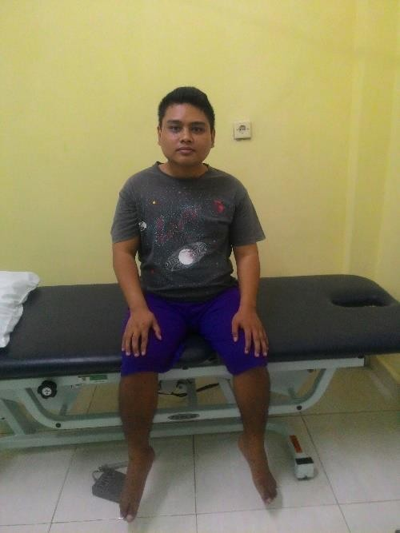
Picture 3. Improved patient mobility to sitting

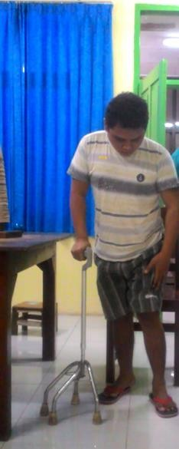
Picture 4. Improved patient mobility to standing
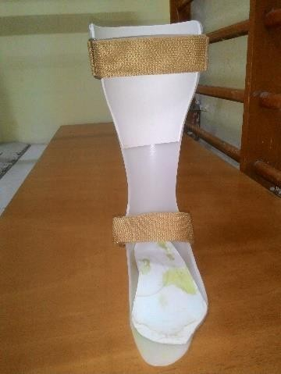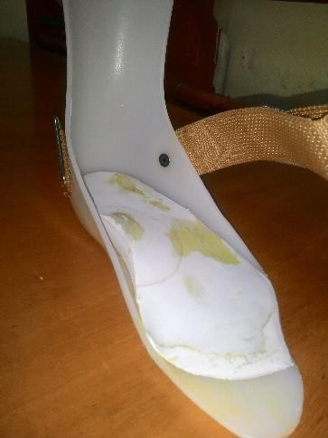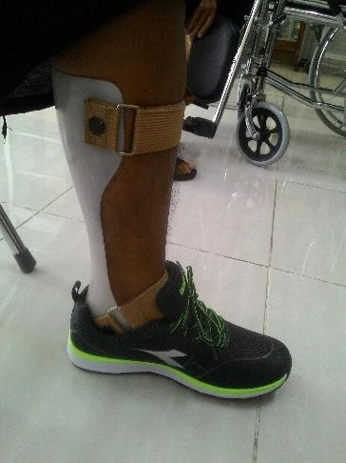
Picture 5. Ankle and Foot Orthosis (AFO) fitted on patient

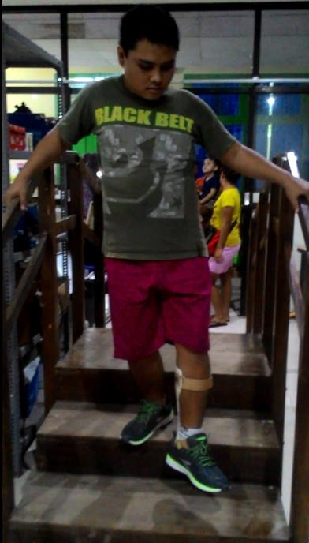
Picture 6. Patient walked with AFO

This patient showed significant improvement from just lying in bed, he is now could walk with the help of walking assistant device (a quadripod) and an AFO (picture 5 and 6).
Also his hand function showed significant improvent from weak grasping to more firm grasping and he is now can do most of his daily activities independently like feeding, grooming, transfer and mobility and need a little assistant in dressing,bathing, toilet use and climbing stairs with Barthel index increasing from 20/100 to 80/100 at the end of five months therapy. According to the literature, occupational therapy addresses the preservation of joints when a lack of strength or an excess in tone or spasticity threatens a joint. The occupational therapy issues of self-care including daily activities such as dressing, bathing and grooming must be addressed and emphasize the need for a planning strategy for the patient.¹ This patient’s treatment was inline according to the literature.
The multidimensional nature of TBI and its consequences make coordinated interdisciplinary teams become the most appropriate strategy for handling patients with traumatic brain injury.

References
- Burke D. Traumatic Brain Injury. In: Frontera WR, editor. Essentials of Physical Medicine and Rehabilitation,5th ed. Saunders Elsevier.Philadelphia ; 2015. p.892-898.
- Elovic E, Baerga E, Cuccurullo S. Traumatic Brain Injury. In : Cuccurullo SJ. Physical Medicinie and Rehabilitation Board Review. 4th ed. Demos Medical Publishing. New York ; 2005. p. 47-63.
- Wagner AK, Arenth PM, Kwasnica C, et al. Traumatic Brain Injury. In : Braddom RL et al. Physical Medicine and Rehabilitation, 5th ed. Elsevier Saunders. Philadelphia ; 2016. p. 961-998.
- Moyer Megan T, Kumar Monisha A. Traumatic Brain Injury : A Journal of Neurocritical Care For The Advanced Practice Clinician. Springer International Publishing AG 2018.
- Pearn Matthew L, Niesman Ingrid R, et al. Pathophysiology Associated With Traumatic Brain Injury : Current Treatments and Potential Novel Therapeutics : A Journal of Cellular and Molecular Neurobiology, Springer 2016.
- PERDOSRI. Traumatic Brain Injury. In: Panduan Pelayanan Klinis Kedokteran Fisik dan Rehabilitasi. Jakarta. 2012. p. 6-9.
- Whyte John, Ponsford Jennie, Watanabe Thomas, Hart Tessa. Traumatic Brain Injury. In: Delisa’s Physical Medicine and Rehabilitation. 5th ed. Lippincott Williams & Wilkins. Philadelphia ; 2010. p. 572-612.
- Almeida TLT, Falkenburg L,et al. Traumatic Brain Injury : Rehabilitation. In: Acta Fisiatr. 2012;19(2):130-7.
- Frontera Joel E,MD , Gutierrez Monica V,MD. Spasticity. In: Frontera WR, editor. Essentials of Physical Medicine and Rehabilitation,5th ed. Saunders Elsevier. Philadelphia ; 2015. p.828-832.
- Kortte Jason, Palmer Jeffrey B. Speech and Language Disorder. In: Frontera WR, editor. Essentials of Physical Medicine and Rehabilitation,5th ed. Saunders Elsevier. Philadelphia ; 2015. p.833-838.
- Solomon Beth, Brewer Charmen, et al. Speech,Language,Swallowing and Auditory Rehabilitation. In: Delisa’s Physical Medicine and Rehabilitation. 5th ed. Lippincott Williams & Wilkins. Philadelphia ; 2010. p. 413-444.
- Fager Susan Koch, Hakel Mark, Brady Sussan, et al. Adult Neurogenic Communication and Swallowing Disorders. In : Braddom RL et al. Physical Medicine and Rehabilitation, 5th ed. Elsevier Saunders. Philadelphia ; 2016. p. 53-58.
- Cameron Michelle H. Superficial Heat. In : Physical Agents and Rehabilitation From Research to Practice, 4th ed. Elsevier Saunders. Philadelphia ; 2013. p. 160- 61
- Smania Nicola, Picelli Alessandro, et al. Rehabilitation Procedures In The Management of Spasticity. European Journal Physical Rehabilitation Medicine 2010;46:423-38
- Cameron Michelle H. Superficial Cold. In : Physical Agents and Rehabilitation From Research to Practice, 4th ed. Elsevier Saunders. Philadelphia ; 2013. p. 129- 140
- Cameron Michelle H. Ultrasound. In : Physical Agents and Rehabilitation From Research to Practice, 4th ed. Elsevier Saunders. Philadelphia ; 2013. p. 173-198.
- Hennessey William J, Uustal Heiki. Ankle-Foot Orthoses. In : Braddom RL et al. Physical Medicine and Rehabilitation, 5th ed. Elsevier Saunders. Philadelphia; 2016. p. 253-26

