LAMPIRAN

Lampiran 1. Scoresheet uji organoleptik
Lembar penilaian sensori nugget

Nama Panelis :…….. Tanggal……….
- Cantumkan kode contoh pada kolom yang tersedia sebelum melakukan pengujian.
- Berilah tanda $√$ pada nilai yang dipilih sesuai kode contoh yang diuji.

Spesifikasi | Nilai | Kode Contoh
 |  | 1 | 2 | 3 | 4 | 5
- Kenampakan
- Lapisan tepung roti kering, cemerlang spesifik produk | 9
- Lapisan tepung roti kering, kurang cemerlang spesifik produk | 7
- Lapisan tepung roti agak basah, agak kusam | 5
- Lapisan tepung roti basah, kusam | 3
- Bau
- Kuat spesifik produk | 9
- Kurang kuat spesifik produk | 7
- Apek | 5
- Masam dan tengik | 3
- Rasa
- Kuat spesifik produk | 9
- Kurang kuat spesifik produk | 7
- Agak masam | 5
- Masam | 3
- Tekstur
- Padat, kompak | 9
- Agak padat, agak kompak | 7
- Agak lembek | 5
- Lembek | 3
Sumber SNI 7758-2013

Lampiran 2. Dokumentasi pembuatan tepung tulang ikan cakalang
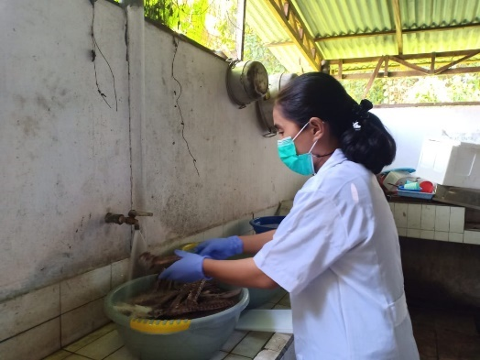
Pencucian tulang ikan cakalang
Tulang ikan cakalang

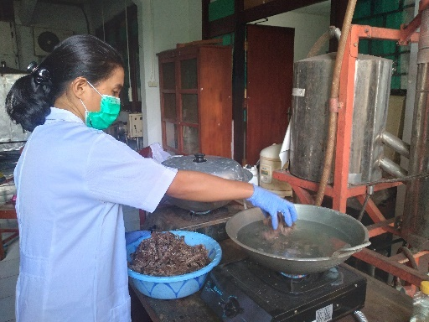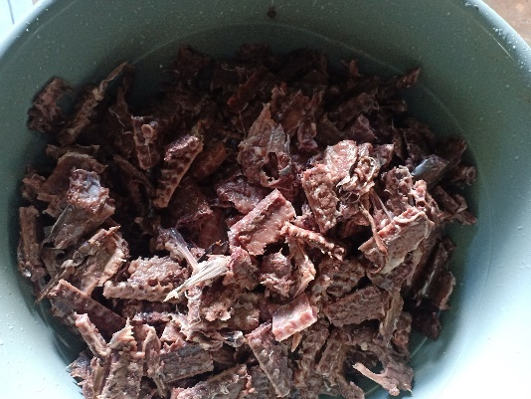
Perebusan
Pemotongan

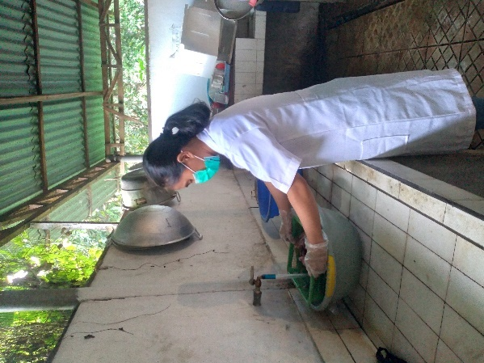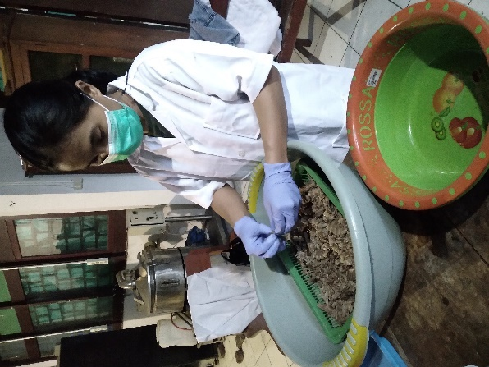
Pemisahan tulang dari daging
Pencucian
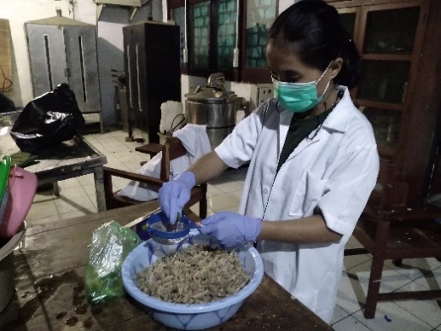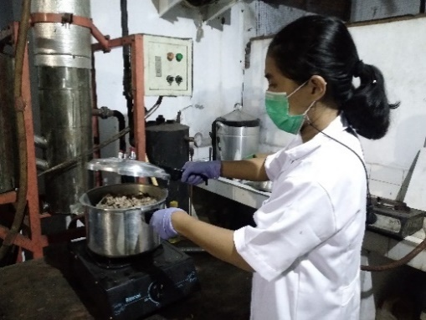
Tulang dipresto
Pengeraman dengan jeruk

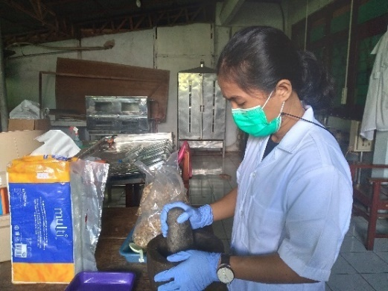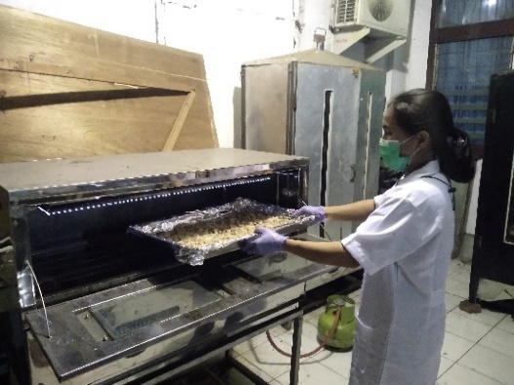
Penghalusan tulang setengah halus
Pengeringan tulang

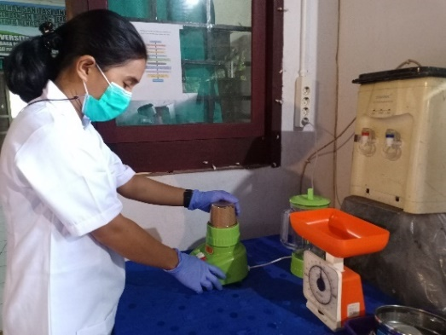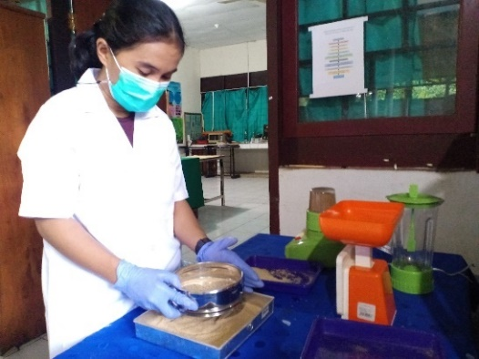
Penghalusan
Pengayakan

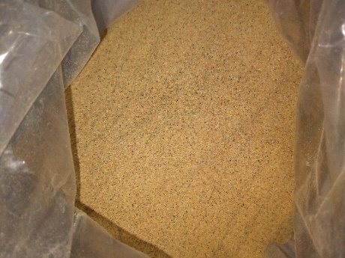
Tepung tulang

Lampiran 3. Dokumentasi pengujian
- Rendemen
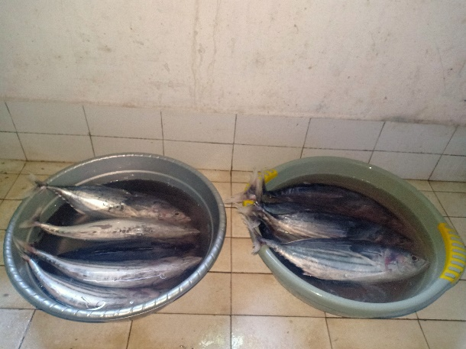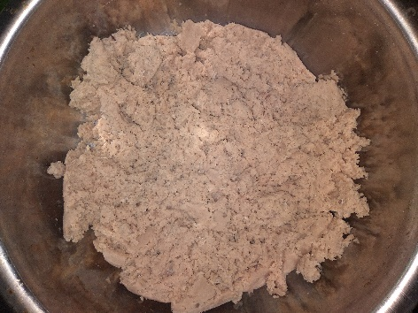
Ikan cakalang
Pasta daging ikan cakalang

- Angka Lempeng Total
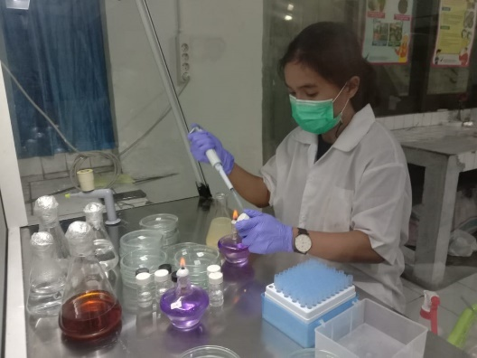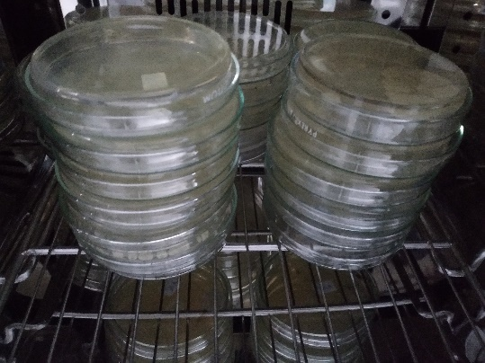
Pengujian ALT
Inkubasi bakteri

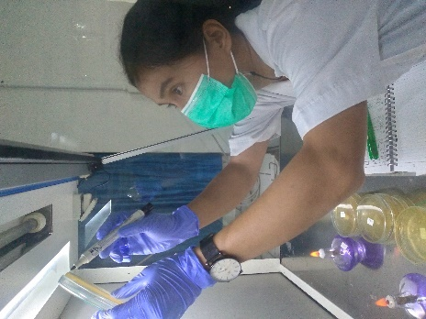
Penghitungan bakteri
- Kadar air

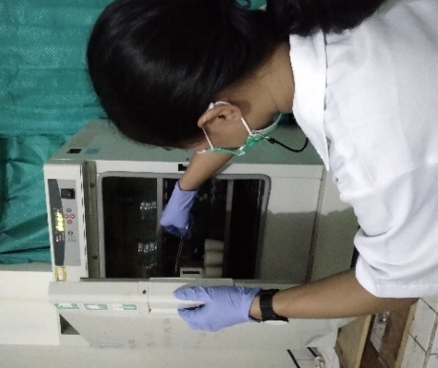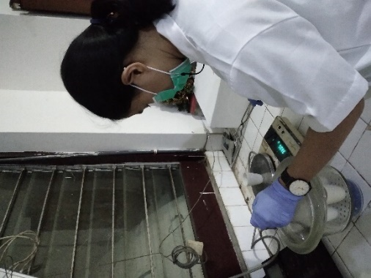
Penimbangan kadar air
Cawan dimasukkan ke dalam oven

- Organoleptik
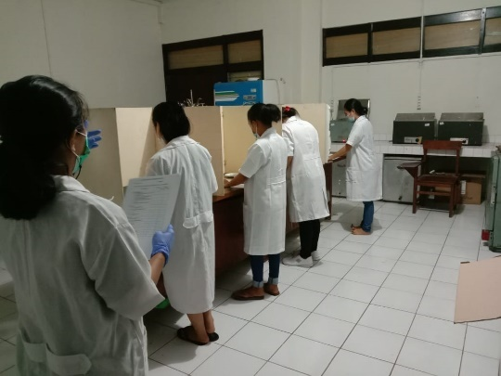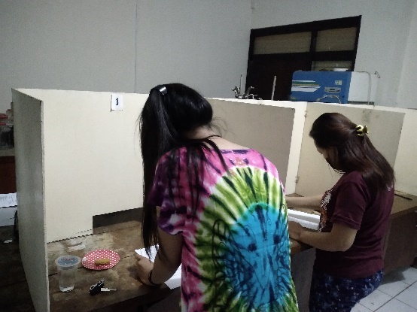
Uji organoleptic pada produk nugget dari tepung tulang
dan daging ikan cakalang

Lampiran 4. Hasil analisis data
- Angka Lempeng Total (ALT)

KODE SAMPEL
A1B1 | A1B2 | A1B3 | A2B1 | A2B2 | A2B3
2 x 10³ | 1,4 x 10³ | 1,2 x 10³ | 1,5 x 10³ | 1,2 x 10² | 9,1 x 10³

- Uji Kadar air
KODE SAMPEL
A1B1 | A1B2 | A1B3 | A2B1 | A2B2 | A3B3
54,64 | 56,39 | 52,06 | 53,43 | 52,65 | 48,82
- Uji organoleptik
LAMA PENYIMPANAN | KENAMPAKAN |  | BAU |  | RASA |  | TEKSTUR
 | 347 | 134 | 347 | 134 | 347 | 134 | 347 | 134
HARI KE-0 | 8,67 | 8,40 | 8,73 | 8,67 | 8,8 | 8,6 | 8,67 | 8,53
HARI KE-3 | 8,2 | 8,13 | 8,53 | 8,47 | 8,6 | 8,4 | 8,47 | 8,4
HARI KE-6 | 8,00 | 7,93 | 8,33 | 8,07 | 7,87 | 7,73 | 8,33 | 8,13

Lampiran 5. Hasil analisis SPSS
- Angka Lempeng Total (ALT)

Descriptive Statistics
Dependent Variable: ALT_LOG
Konsentrasi_Tepung_Tulang | Waktu_Penyimpanan | Mean | Std. Deviation | N
A1 | B1 | 3.3100 | . | 1
 | B2 | 3.1500 | . | 1
 | B3 | 3.0800 | . | 1
 | Total | 3.1800 | .11790 | 3
A2 | B1 | 3.1900 | . | 1
 | B2 | 3.0800 | . | 1
 | B3 | 2.9600 | . | 1
 | Total | 3.0767 | .11504 | 3
Total | B1 | 3.2500 | .08485 | 2
 | B2 | 3.1150 | .04950 | 2
 | B3 | 3.0200 | .08485 | 2
 | Total | 3.1283 | .11856 | 6

Tests of Between-Subjects Effects
Dependent Variable: ALT_LOG
Source | Type III Sum of Squares | df | Mean Square | F | Sig.
Corrected Model | .069ª | 3 | .023 | 55.560 | .018
Intercept | 58.719 | 1 | 58.719 | 140925.160 | .000
Konsentrasi_Tepung_Tulang | .016 | 1 | .016 | 38.440 | .025
Waktu_Penyimpanan | .053 | 2 | .027 | 64.120 | .015
Error | .001 | 2 | .000
Total | 58.789 | 6
Corrected Total | .070 | 5
a. R Squared = .988 (Adjusted R Squared = .970)

- Kadar Air
Descriptive Statistics
Dependent Variable: Kadar_Air
Konsentrasi_Tepung_Tulang | Waktu_Penyimpanan | Mean | Std. Deviation | N
A1 | B1 | 54.6400 | . | 1
 | B2 | 56.3600 | . | 1
 | B3 | 52.0600 | . | 1
 | Total | 54.3533 | 2.16429 | 3
A2 | B1 | 53.4300 | . | 1
 | B2 | 50.7300 | 2.71529 | 2
 | Total | 51.6300 | 2.47314 | 3
Total | B1 | 54.0350 | .85560 | 2
 | B2 | 52.6067 | 3.77519 | 3
 | B3 | 52.0600 | . | 1
 | Total | 52.9917 | 2.55835 | 6

Tests of Between-Subjects Effects
Dependent Variable: Kadar_Air
Source | Type III Sum of Squares | df | Mean Square | F | Sig.
Corrected Model | 25.353ª | 4 | 6.338 | .860 | .659
Intercept | 15188.460 | 1 | 15188.460 | 2060.067 | .014
Konsentrasi_Tepung_Tulang | 13.367 | 1 | 13.367 | 1.813 | .407
Waktu_Penyimpanan | 8.163 | 2 | 4.082 | .554 | .689
Konsentrasi_Tepung_Tulang * Waktu_Penyimpanan | 5.582 | 1 | 5.582 | .757 | .544
Error | 7.373 | 1 | 7.373
Total | 16881.426 | 6
Corrected Total | 32.726 | 5
a. R Squared = .775 (Adjusted R Squared = -.126)

